EXPERİMENT - 4
DTL-TTL LOGIC GATES
4.1 OBJECTIVE
The purpose of this experiment is to provide an understanding of some of the characteristics of diode-transistor logic circuit (DTL) and the transistor-transistor logic (TTL) family cicrcuits.
4.2 THEORY
Logic Gates are either classified by their logical functions or by their logical families. Understanding of pysical capabilities and limitations of a logical element is important in any implementation of a digital system.
The logic family refers to the general physical realization of a logical element, such as the TTL,emitter-cuopled logic (ECL), or complementary metal-oxide semiconductor (CMOS) logic families. Within each logic family are one or more logic series that have distinctive characteristics, relative to other series within the same logic family. For example, in the TTL logic family, there are several logic series: the 74 standart, 74L low-power, 74H high-speed, 74S standart Schottky, 74LS low-power Schottky series, and 74ALS advanced low-power Schottky series.
4.2.1 Basic DTL NOT Gate Circuit
The basic DTL NOT gate circuit and its voltage-transfer characteristic (VTC) are shown in Fig.4.1. When transistor is cut off, $V_{O}$= $V_{OH}$=$V_{CC}$. Since the input diode of loadgate is reverse biased and only reverse (or leakage) current flow in the collector resitor $R_{C}$ of the driving gate, $V_{OH}$ is independent of the number of load Gates connected to the output. When the transistor is in the saturation region, $V_{O}$= $V_{OL}$=$V_{CE(SAT)}$. The inverting transistor will be at the edge of conducting when $V_{BE}$= $V_{BE(on)}.$
$V_{IL}$= $V_{BE\left(on\right)}$+2$V_{D(on)}$-$V_{D(on)}$=$V_{BE\left(on\right)}$+$V_{D(on)}$
The inverting transistor will be at the edge of simulation when $V_{BE}$=$V_{BE(sat)}.$
$V_{IH}$= $V_{BE\left(sat\right)}$+2$V_{D(on)}$-$V_{D(on)}$=$V_{BE\left(sat\right)}$+$V_{D(on)}$
Logic swing is given as
LS=$V_{OH}-V_{OL}$
Noise margins
N$M_{H}$=$V_{OH}-V_{IH}$
N$M_{L}$=$V_{IL}-V_{OL}$
For low output, fan-out(N) can be written as
Fan-out = N = $\frac{Total output current of gate}{Drive current for each smilar gate}$ = $\frac{I_{LT}}{I_{1}}$

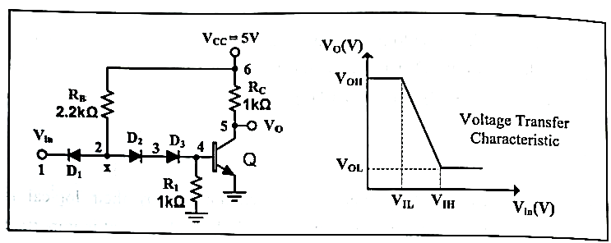
Figure 4.1 Basic DTL circuit and its voltage-transfer characteristic.

4.2.2 Basic TTL NOT Gate Circuit
The basic TTL NOT gate circuit are shown in Figure 4.2. When the input is logic 0, Q4 transistor is forward-biased and Q4 is in saturation ragion, and Q5 is in cutt-off region. $V_{O}=V_{CC}$= logic 1. When the input is logic 1, Q4 is in inverse active mode and Q5 is in saturation region. $V_{O}=V_{CE\left(sat\right)}=logic 0.$

Figure 4.2 Basic TTL circuit and CA3146 IC.

4.3 PRELIMINARY
$V_{BE}\left(on\right)=V_{D}\left(on\right)=0.7V, V_{BE}\left(sat\right)=0.8V,V_{CE}\left(sat\right)=0.2V,β$=100, $β_{R}=0.1.$
4.3.1 For DTL circuit as shown in Figure 4.1,
- Sketch the VTC,
- Find and replace $V_{OH},V_{OL}{,V}_{IH}{,V}_{IL}$ and noise margins listed below.

 | Calculated |  | PSpice |  | Experimental
 | DTL | TTL | DTL | TTL | DTL | TTL
$$V_{OH}$$
$$V_{OL}$$
$$V_{IH}$$
$$V_{IL}$$
$$NM_{H}$$
$$NM_{L}$$
Table 4.1
4.3.2 Repeat part(4.2.1) for TTL circuit given in Figure 2.2.

4.3.3 Perform a PSpice analysis (Run a DC sweep from 0V to 5V on the input $V_{in}$) of circuit shown in Figure 4.1.
- Obtain $V_{o}-V_{in}$ voltage transfer characteristics(VTC) of the circuit.
- Using VTC, find and replace $V_{OH},V_{OL}{,V}_{IH}{,V}_{IL}$and noise margins listed in Table 4.1.
4.3.3 Repeat part (4.3.3) fort he circuit given in Figure 4.2.

4.4 EXPERIMENTAL PROCEDURE
- $V_{in}=2.5+2.5sin⁡(2π100t)$.
4.4.1 Setup the circuit as shown in Figure 4.1.
- Observe and plot the VTC.
- Find and replace $V_{OH},V_{OL}{,V}_{IH}{,V}_{IL}$ and noise margins listed in table 2.1.
4.4.2 Repeat part(4.4.1) for TTL circuit given in Figure 2.2.

DTL TTL
4.5 CONCLUSIONS
4.5.1 Compare the results obtained in the preliminary and experimantal results. If there exist some differences, explain the reasons.

4.6 EQUIPMENT LIST
- Resistors : 2.2kΩ, 4.7kΩ
- IC : CA3146
- Rectifier diodes : 3x1N4148
- Standart Set Equipment :

