FE 132 ORGANIC CHEMISTRY LABORATORY
EXPERIMENT 2: Recrystallization
INTRODUCTION
Recrystallization is a useful purification method for most organic compounds that are solids at room temperature. The selection of a proper solvent is the most critical part of the recrystallization procedure. Organic solids are usually more soluble in hot solvent than in a comparable volume of cold solvent. The process of recrystallization involves dissolution of the solid in an appropriate solvent at elevated temperature and the subsequent reformation of the crystals upon cooling. This way, many impurities will stay in solution and your target compound is purified. However, it is not possible to recover your entire compound following a recrystallization. To maximize your yield, it is very important to only use a minimum amount of hot solvent.
Choosing the appropriate solvent is the most challenging part of the recrystallization. In choosing a solvent, remember that “like dissolves like”, which means that a nonpolar compound will dissolve well in a nonpolar solvent, and a polar compound will dissolve well in a polar solvent. Also note whether a solvent is flammable or not and find its boiling point. This will enable you to select an appropriate heating device. Generally speaking, solvents with boiling points below 100°C should be heated in a water bath (NO OPEN FLAME), above 100°C can be heated directly on a hot plate or you may use a sand bath.
In this experiment, recrystallization from a single solvent (water) will be illustrated. Recrystallization is a purification technique; it allows us to remove impurities in a sample. Selecting a solvent is crucial for recrystallization of an organic solvent. An ideal recrystallization solvent should:
- Dissolve the entire compound at the boiling point of the solvent.
- Dissolve very little or none of the compound when the solvent is at room temperature.
- Have different solubility for the compound and the impurities
- Have a boiling point below the melting point of the compound so that the compound actually dissolves, not melts, in the hot solvent.
- Have a relatively low boiling point
- Not react with the substances to be purified
Once you have selected your solvent you are ready to recrystallize your sample. The process of recrystallization can be broken into the following steps:
- Selection of an appropriate solvent or mixture of solvents (consult table)
- Dissolution of the solute using a minimum amount of hot solvent
- Decoloration of the solution if necessary (with an activated form of carbon)
- Filter: Removal of suspended solids (through filtration of the hot solution)
- Crystallization of the solid from the solution as it cools
- Collecting the purified solid by filtration
- Washing the crystals with an appropriate solvent to remove impurities
- Drying the crystals
Traces of colored matter or resinous impurities may sometimes be removed with selective adsorbents, such as finely divided charcoal. A small amount of decolorizing charcoal is added to the hot solution before it is filtered. Excess of decolorizing agent should be avoided, however, because it may also adsorb appreciable amounts of the substance being purified.
The solubility of a solute in a solvent is a function not only of the chemical structure of the two components, but also of the temperature. Do you remember that temperature is a measure of a molecule’s kinetic energy? Ordinarily the solubility of a solid in a liquid increases with temperature, and, in some instances, the effect may be very marked. This phenomenon is of great importance to the chemist because it is the basis for the purification of solids by recrystallization.
If a solid is dissolved in a hot solvent and the solution is cooled, the saturation point may be reached. Any subsequent cooling of the solvent results in the separation of solid by recrystallization. If the original material contains any foreign matter, a highly specific purification procedure using an appropriate solvent can be devised. Contaminants that are insoluble in the solvent can be separated by filtration of the hot solution; small amounts of those that are highly soluble in the solvent will remain in solution as the desired product crystals are formed and removed by filtration. Occasionally it is necessary to remove traces of highly colored impurities by boiling the solution with decolorizing charcoal (on which the impurities absorb) removing the charcoal by filtration, and proceeding with the crystallization.
This purification method takes advantage of the differences in solubility between the compound and its impurities. Most of the impurities will remain dissolved in the cool solvent, allowing them to be removed when the sample is isolated by vacuum filtration. Some of the impurities may not dissolve even in hot solvent, requiring a hot filtration to remove them.
Occasionally the crystals may not form as the solution cools. A few steps can be taken to induce crystallization in these cases. These include: (a) using a seed crystal, (b) scratching the inside of the flask, (c) cooling the mixture in an ice bath, and (d) removing some of the excess solvent by boiling, then allowing the mixture to cool again. Seed crystals and flask scratching both induce crystallization by providing a surface on which the crystals can begin forming. It is important to always save some impure sample to use as seed crystals.
Vacuum or Suction Filtration
The pure crystals generated by recrystallization can be collected by vacuum filtration. In this process a Buchner funnel is in a filter flask with a rubber adapter fitting between the two. (A Hirsch funnel can be used for samples smaller than a gram.) A circle of filter paper is placed inside the funnel. The paper should be big enough to cover the holes in the funnel but small enough to lay flat. The filter flask should be connected to a source of vacuum with thick wall tubing (if the tubing collapses under vacuum you’ve got the wrong tubing!). A trap should be placed between the filter flask and the source of vacuum if there is any chance of vapor or liquid being drawn into the vacuum line. A clamp and ring stand can be used to secure the flask so that it will not fall over.
Once the vacuum filtration setup is assembled add a small amount of the solvent or supernate to moisten the filter paper. Turn on the vacuum to seal the paper against the funnel and pour the material to be filter into the funnel evenly. Make sure the filter flask is never more than half full. If this occurs turn off the vacuum and pour out the filtrate into another flask. This filtrate can also be used to rinse any remaining crystals into the funnel. After removing the filtrate, the cold wash liquid can be poured into the funnel with the vacuum off. After 1-2 minutes turn on the vacuum and leave it on for several minutes to dry the crystals.
Once the flask is cool and crystals have precipitated out, collect by vacuum filtration. If crystallization does not occur even after the solid is cold, scratch the inside of the flask with a glass rod or add a seed crystal. If crystallization still does not occur, you probably added more solvent than was necessary. Reduce the volume of the solution by heating it again just until the solution turns cloudy or crystals appear. Add enough of your solvent to dissolve the crystals and let cool as you did before.

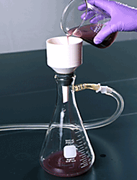

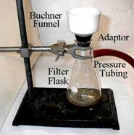
* If solids (sand, dirt, etc.) remain at this step, filter the hot solution to remove any insoluble left in the flask.

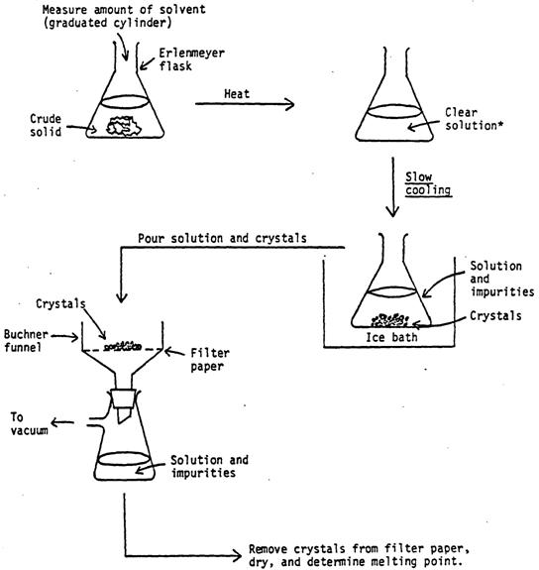
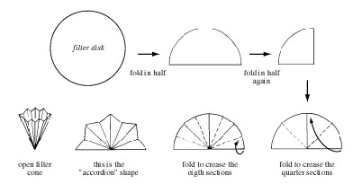
Procedure
- Take 1 g (note the exact weight of solid, i.e., 1.007 g) of acetanilide and solve in 25 ml of distilled water by heating the solution
- When you have a clear solution, cool down the solution in an ice bath
- When you obtain pure crystals inside the solution apply the vacuum filtration with your instructor
- Dry the filter paper 24 hours
- Weigh the recovered crystals and note the value
- Calculate the % recovery

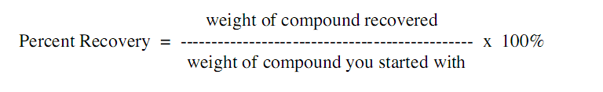
Tips:
  - Adding too much solvent to dissolve the solute will prevent later recrystallization causing the loss of the product.
  - After the solute is dissolved, do not use vacuum filtration to remove the solid impurities because the air flow will cause recrystallization of the solution before the impurities are removed.
  - Never use boiling chips in crystallization because they are hard to separate from the crystals, resulting in an impure product.
Once crystals are drying on the filter paper and watch glass, do not heat the watch glass in an attempt to speed up the drying process because the crystals may melt.
Discussion questions
- Briefly describe how insoluble impurities are removed during a recrystallization?
- Briefly describe how soluble impurities are removed during a recrystallization?
- What are the characteristics of an ideal recrystallization solvent?
- How much solvent should be used in recrystallization procedure?
- Define precipitation and explain the differences between recrystallization and precipitation.
- Sugar is not ionizable substance but it also dissolves in water. How do you explain this phenomenon?

