FE 132 ORGANIC CHEMISTRY LABORATORY
EXPERIMENT 9: HYDROCARBONS
INTRODUCTION
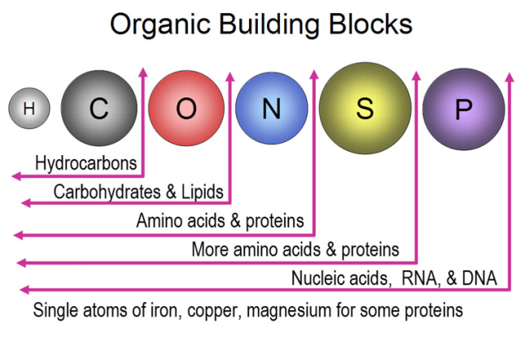
Hydrocarbons are compounds composed exclusively of hydrogen and carbon atoms. Carbon atoms are unique in their ability to connect to each other in order to form molecular chains of indefinite length.
The molecular structures that can be assembled in this manner are limited primarily by one's imagination. However, within this framework, there are certain patterns and certain types of hydrocarbon groupings which share properties and which deserve individual attention.
These include:
- Alkanes - hydrocarbon chains containing only single bonds between carbon atoms;
- Alkenes - hydrocarbon chains containing at least one double bond between any two carbon atoms;
- Alkynes - hydrocarbon chains containing at least one triple bond between any two carbon atoms;
- Aromatics - hydrocarbon chains which contain at least one benzene ring that is one ring of six carbon atom containing three single bonds and three double bonds.

Hydrocarbons are organic molecules that consist exclusively, or primarily, of carbon and hydrogen atoms. They come in two flavors:
- aliphatic hydrocarbons, which consist of linear chains of carbon atoms;
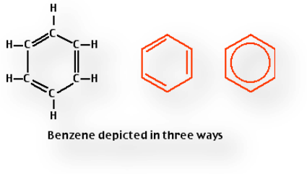
- aromatic hydrocarbons, which consist of closed rings of carbon atoms.

The building block of aromatic hydrocarbons is the benzene ring.
Aromatic compounds derive their names from the fact that many of these compounds in the early days of discovery were grouped because they were oils with fragrant odors, hence the name aromatic.

The current definition of aromatic compounds includes only those with a benzene ring, which is a special six carbon ring compound with three alternating double bonds. This structure imparts unique properties to benzene which are different from other ring compounds.

The three double bonds are not restricted to the positions shown but are free to pass around the ring. This is sometimes indicated by drawing the benzene ring as it is on the far right.

Alkanes | Alkenes | Alkynes
SATURATED means that each carbon is bonded to four other atoms through single covalent bonds. Hydrogen atoms usually occupy all available bonding positions after the carbons have bonded to each other. | UNSATURATED hydrocarbons contain either double or triple bonds. Since the compound is unsaturated with respect to hydrogen atoms, the extra electrons are shared between 2 carbon atoms forming double or triple bonds.
PARAFFINS which is derived from a Latin word meaning "little activity" and means that the compounds are very unreactive. | Alkenes are also called OLEFINS because they form oily liquids on reaction with chlorine gas. | Alkynes are also generally known as ACETYLENES from the first compound in the series.

Procedure:
Part A: Reaction of Alkenes with Bromine (Br₂)
Hydrocarbons with multiple bonds (unsaturated hydrocarbons except most cycloalkanes) react with bromine. Tetrachloromethane (carbon tetrachloride) or cyclohexane is usually used as solvents because they are unreactive toward both bromine and hydrocarbons that have multiple bonds. Alkenes and alkynes undergo an addition reaction with bromine. The double bond of an alkene becomes a single bond and one bromine atom becomes bonded to each of the carbons that had shared the double bond. No other product is formed; the alkene and bromine simply add together, which is why it’s called an addition reaction. The triple bond of an alkyne also undergoes an addition becoming a single bond, but in this case each of the carbons that had been joined by the triple bond will now hold two bromine atoms. Examples follow.
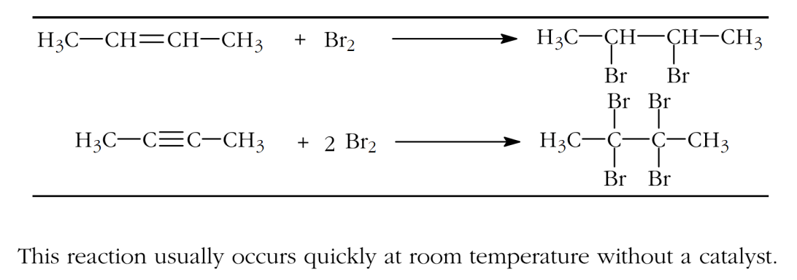
Bromine is a reddish-brown color. All of the other substances in these reactions are colorless. So, when bromine is added to an alkene or alkyne the red-brown color dissipates quickly, often almost instantly.
Alkenes, but not alkanes or aromatic hydrocarbons will react with Br₂ in solution to produce the corresponding alkyl bromide (or dibromoalkane). The yellow/orange color of Br₂ will disappear as it reacts with the alkenes; the bromoalkane products are usually colorless.
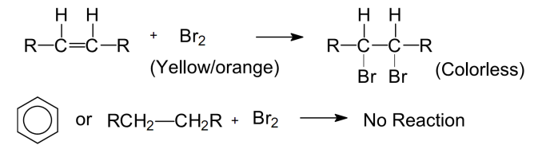
  - Place 5 drops of each of the following hydrocarbons in clean separate test tubes: hexane, cyclohexane, hexene, cyclohexene, m-xylene and your unknown.
  - Add 2 drops of bromine solution to each test tube and observe whether there is any change in color of the bromine solution indicating a reaction with the hydrocarbon.
  - Record your observations on the Report.

Part B: Aromatic Bromation
Aromatic rings react with bromine in a substitution reaction; this reaction is slower than the addition of bromine to an alkene or alkyne and may require a catalyst. Iron (III) bromide is a good catalyst for this reaction. If iron filings are added to a mixture of the aromatic compound and bromine, iron (III) bromide will form. Note that hydrocarbon groups that may be attached to the aromatic ring will react as described above.
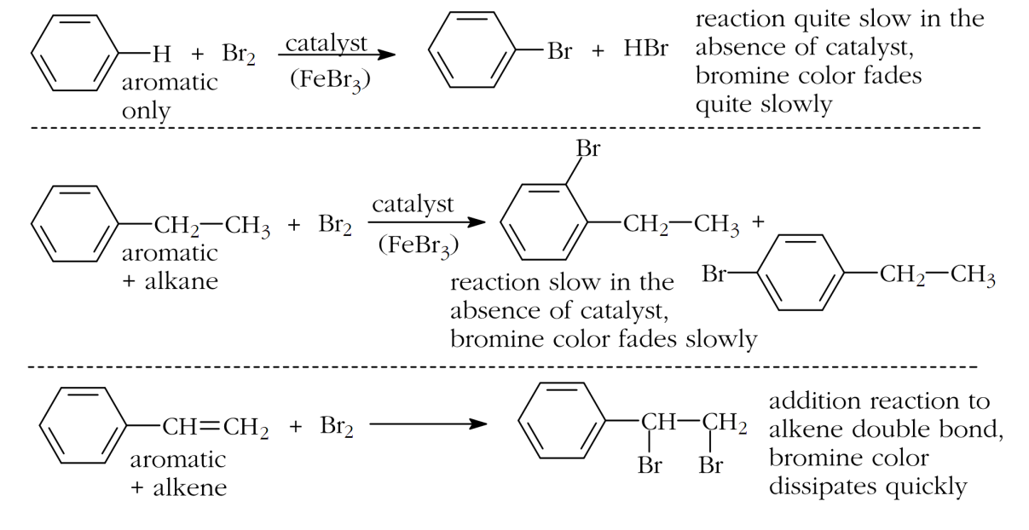
  - Into two separate test tubes, place 1 ml of benzene.
  - Add 2-3 drops of bromine solution in each test tube.
  - To one of the benzene sample, add a few iron fiilings.
  - Place both tubes in a warm water-bath at 50°C for 30 min.
  - Observe any color changes.
  - In which sample did a color change occur more rapidly.

Part C: Baeyer’s Test: Reaction with Aqueous Potassium Permanganate
Potassium permanganate is an oxidizing agent that reacts with unsaturated aliphatic hydrocarbons, but does not react with alkanes or aromatic hydrocarbons. The dilute KMnO₄ solution has a deep purple color; if there is no reaction you should see no color change. When it reacts with unsaturated aliphatics it produces MnO₂, a brown precipitate. This reaction is useful as a test for the presence of a multiple bond, if there is no other easily oxidizable group, such as an alcohol or aldehyde.
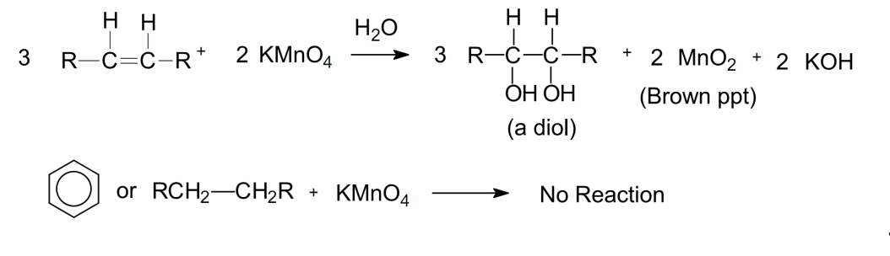
  - Place 5 drops of each of the following hydrocarbons in clean separate test tubes: hexane, cyclohexane, hexene, cyclohexene, m-xylene and your unknown.
  - Add 2 drops of dilute KMnO₄ solution to each test tube and shake.
  - Record your observations on the Report Sheet.

Part D: Reaction with Concentrated Sulfuric Acid
Alkenes react with concentrated sulfuric acid at room temperature in an addition reaction that produces an alkyl sulfonic acid. The alkyl sulfonic acid is highly polar and is soluble in the polar sulfuric acid with sufficient stirring. The non-polar alkene is not soluble in the polar concentrated sulfuric acid, but dissolves as it reacts and the mixture is stirred. [A second, related issue here is that the alkene is not capable of forming hydrogen bonds, while sulfuric acid and the alkyl sulfonic acid can. Hydrogen bonding is an especially strong type of dipole-dipole attraction. In order for H-bonding to occur at least one of the molecules must have hydrogen (directly) bonded to a fluorine, oxygen or nitrogen. This hydrogen will be strongly attracted to a fluorine, oxygen or nitrogen in another molecule. Hydrogen bonding is a very important phenomenon, especially in biological systems.] An example follows.
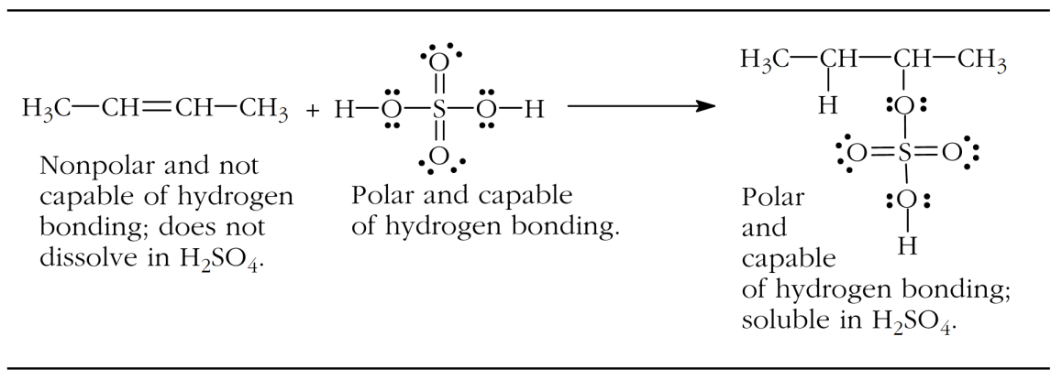
Alkynes react slowly or not at all with concentrated sulfuric acid unless a catalyst is present (HgSO₄). They may darken but likely will not dissolve in the sulfuric acid. Alkanes do not react. Aromatic hydrocarbon rings react quite slowly at room temperature (undergoing a substitution reaction in which hydrogen bound to a carbon in the ring is replaced by an -SO₃H group).
  - 0,5 ml benzene is added to 3 ml of concentrated H₂SO₄ with gentle shaking
  - Does benzene dissolve? Is heat evolved?
Part E: Nitration of Aromatic Hydrocarbons
Aromatic compounds can be directly nitrated using a mixture of concentrated nitric acid and sulphuric acid.

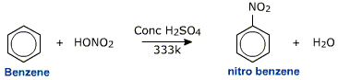

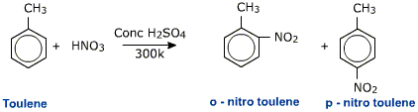
This reaction is an example of electrophilic substitution of benzene. The electrophile is a nitronium NO₂⁺ ion.
  - To 1 ml of the hydrocarbon add a mixture of 1 ml concentrated HNO₃ and two drops of concentrated H₂SO₄.
  - Heat at 50°C for 15 min.
  - Pour into 5 ml water
  - Note the heavy oil separated

Discussion questions:
- How would you describe the difference between saturated and unsaturated hydrocarbons and what is a distinguishing feature of aromatic hydrocarbons.
- Describe the relative reactivity of alkanes, alkenes and aromatic hydrocarbons with respect to their chemical reactions. You may want to give some examples in your answer.
- Alkanes find many commercial uses. Give at least 3 commercial uses for alkanes and name one alkane that is used as you describe. You may want to give the names of 3 specific alkanes and describe how each is used.
- Did you observe any differences between the reactivity of cycloalkanes or cylcoalkenes relative to the straight chain hydrocarbons in any of the tests where they were compared?
- Do you expect the aromatic hydrocarbons to react in a similar way to the cyclic alkenes, since they are both cyclic compounds and have a double bond? Explain.
- Why was Br₂ dissolved in cyclohexane and not in water?
- Which hydrocarbons reacted with KMnO₄? Describe the color changes observed.
- How can the potassium permanganate test be used to distinguish between saturated and unsaturated hydrocarbons?
- Suggest a procedure for the separation of the components of a mixture containing propane, propylene and propyne.

