**FE 132 ORGANIC CHEMISTRY LABORATORY**

**EXPERIMENT 4: PURIFICATION OF ORGANIC COMPOUNDS**

**Introduction:**

Earlier in your chemistry career you learned that Raoult's Law allows us to calculate the vapor pressure above a solution given the concentration of the solute (X solute) and the vapor pressure of the pure solvent:

Psolvent  =  X solute Posolvent

If both the solvent and solute are volatile, then Dalton's law of partial pressures shows us that the total pressure above the solution is the sum of the partial pressures of each solvent and solute:

Ptotal =  Psolvent  +  Psolute

Using these principles, we can construct a Raoult's law plot that shows the composition of both the liquid and the vapor above the solution:

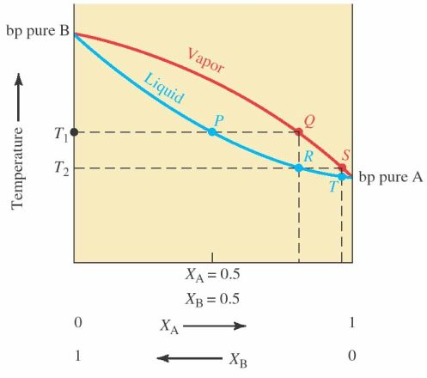

If for instance, you start with a 50:50 mixture of two volatile components, A and B, you can see that the composition of the liquid is represented by point 'P' on the blue line.  However, the composition of the vapor above this solution is considerably enhanced in the lower boiling component 'A' (point 'Q' on the red line).  If this vapor is collected and cooled, the liquid will have the composition at point 'R'.  The process of going from liquid to vapor to liquid again (points 'PQR') is called a single plate distillation.  If you then take the liquid at point 'R' and collect the vapor above it (point 'S') and cool it to point 'T', you have completed a second single plate distillation and have further purified component 'A' (lower boiling component).  This distillation process can be continued until the desired degree of purity is achieved.

**Distillation** is a purification technique in which compounds with different boiling points can be separated by controlled heating.  Vapors from a sufficiently heated sample can be recondensed and collected, purer than the initial mixture. The liquid which has not vaporized is called the **residue**, and the liquid which is collected in the receiver is called the **distillate**.

Since not all chemicals distill the same way, there are several distillation techniques can be preferred depending on the nature of constituents to be purified or to be separated. These include **simple distillation, fractional distillation, steam distillation and vacuum distillation**.

A **simple distillation (figure 1)** is for purifying liquids of one component (separating nonvolatile liquid impurity or to purify a liquid from solid contaminants), multiple liquids where the differences in boiling points is very large (a low boiling liquid from a high boiling liquid) (b. p. difference around 50-70°C). Simple distillations are not effective in removing multiple solvents from one another with a high degree of success.

Separating liquids boiling below 150°C at one atmosphere (1 atm) from

* 1. Nonvolatile impurities.
  2. Another liquid boiling at least 25°C higher than the first. The liquids should dissolve in each other.

In **fractional distillation,** a fractionating column is inserted between the distillation flask and the distillation head. The fractionating column provides a large surface area in which the mixture can be continuously vaporized and condensed.

Separating liquid mixtures, soluble in each other, that boil at less than 25°C from each other at 1 atm.

The principle of a fractionating column is that, as the vapors ascend the column from the boiling mixture below, the high boiling components are condensed and returned to the flask, the ascending column of vapor being thus steadily “scrubbed” by the descending column of liquid condensate. The ascending column of the vapor becomes therefore steadily richer in the lowest boiling component and the descending column of condensate steadily richer in the highest boiling component.

Figure 2 represents the typical curve for simple and fractional distillation. In an ideal fractional distillation, two distinct fractions are obtained. The first corresponds to the component with the lower boiling point and the second to the high-boiling point component. What characterizes a good fractional distillation is the sudden increase in temperature between both fractions, and in other words, a very small volume distilled at temperatures other than the boiling points of the pure liquids. In simple distillation, a much more gradual increase in temperature is observed, reflecting the impure nature of the distillate

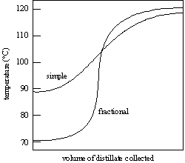

**Figure 2. Simple and fractional distillation curves**

**Vacuum distillation** is used for separating liquids boiling above 200◦C at 1 atm from

* 1. Nonvolatile impurities.
  2. Another liquid boiling at least 25°C higher than the first. They should dissolve in one another.

**Steam distillation** is used for separating mixtures of chemicals such as oils, resins, hydrocarbons, etc. which are insoluble in water and may decompose at their B.P.

Isolating tars, oils, and other liquid compounds that are *insoluble*, or slightly soluble, *in water at all temperatures*. Usually, natural products are steam distilled. They do *not* have to be liquids at room temperatures. (For example, caffeine, a solid, can be isolated from green tea.)

**Background :** The boiling point of eugenol, an oil found in cloves, is 248 °C, but it can be isolated at a lower temperature by performing a co-distillation with water, this process is also known as a steam distillation.

Since eugenol is not soluble in water, the concentration of the eugenol in the vapor over the boiling eugenol–water suspension does not depend on concentration of the eugenol. The relative amounts of eugenol and water in the vapor simply depend on the vapor pressures of the pure materials. The vapor pressure of water at 100 °C is 760 Torr, and the vapor pressure of eugenol at 100 °C is approximately 4 Torr; therefore, the vapor is roughly 0.5 % eugenol. (Note, the suspension boils when its vapor pressure is equal to the external pressure. Since both the eugenol and the water are contributing to the vapor pressure of the suspension, the suspension will boil before either pure substance would normally boil.)

Since the distillate will contain both water and eugenol, the eugenol must be extracted from the water using an organic solvent. Once the eugenol is extracted into an organic solvent, the organic layer is separated from the aqueous layer and dried. The eugenol is finally isolated by evaporation of the organic solvent.

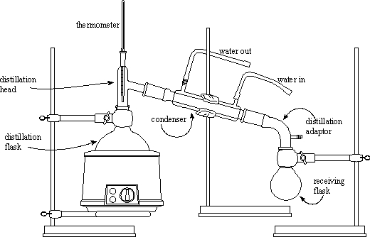

**Figure 1 Simple distillation set-up**

**Notes:**

* The bulb of the thermometer is opposite the exit to the condenser. You want the temperature of the exit vapors since it is these that will condense.
* The delivery bend is vented so that when the apparatus is heated the joints aren't pushed apart by expanding gas. Never draw a closed apparatus.
* Water goes in at the bottom of the condenser jacket and out at the top.
* Note the structure of the condenser - the water jacket is separate from the tube down the middle!

1. **Experimental (simple distillation):**

Perform a simple distillation of a mixture consisting of 35 ml of acetone and 35 ml of water. Take temperature readings at first drop and each 0, 5 ml increment. Record the temperature readings for every 10 ml distillate collected. Continue until you have distilled 35 ml.

Make a plot of temp (˚C) & distillate (ml), Discuss the results, answer the questions 1-5.

1. **Experimental (Steam Distillation):** The isolation of eugenol from cloves

**Reagents** Whole cloves; 5% potassium hydroxide, KOH, solution; 5% hydrochloric acid, HCl, solution; dichloromethane, CH2Cl2, b.p. 41°C; distilled water, H2O; granular anhydrous sodium sulfate, Na2SO4; saturated sodium chloride, NaCl, solution.

**Procedure: Co-distillation**

Combine 15 ml of water and 1 g of crushed, ground cloves in a 25-mL round-bottom flask. Add a spin bar to the 25-mL round-bottom flask and assemble the micro scale distillation apparatus (the flask, a Hickman still head, and a water condenser). Make certain that the ground cloves are well wetted and soak the ground cloves for 15 minutes. Turn on the cooling water for the condenser and heat the clove–water suspension using a sand bath and a heating mantle. The temperature of the sand bath should be maintained at approximately 130 °C and the bottom of the still should be wrapped with aluminum foil. Be aware, heating the suspension too vigorously may result in foaming, which will contaminate the distillate with ground cloves. Periodically transfer the distillate from the Hickman head to a 15 mL screw cap centrifuge tube and continue the steam distillation until 5–8 mL of distillate have been collected.

Discuss the results, answer the questions 6-11.

**Extraction**

To the water–eugenol emulsion add 2 mL of CH2Cl2. Cap the tube and shake (remember to vent the tube frequently). Allow the layers to separate and transfer the CH2Cl2–eugenol solution to a clean, dry 5-mL conical vial. Make certain that no water is transferred during this step. Repeat the extraction and transfer steps twice more and each time transfer the CH2Cl2–eugenol solutions to the 5-mL conical vial described previously. When performing these two extractions and transfer steps use 1-mL aliquots of CH2Cl2. Dry the CH2Cl2–eugenol solution with 2-3 micro spatulas of anhydrous sodium sulfate.

**Evaporation**

Transfer the dried CH2Cl2–eugenol solution to a clean dry 5-mL conical vial. Rinse the drying agent with a few drops of CH2Cl2 and transfer CH2Cl2 rinse to the 5-mL conical vial. In a fume hood, evaporate the CH2Cl2 using a hot water bath (approximately 40 °C max. 50 °C) and a gentle stream of compressed air.

**Discussion questions**

1. [*Do the quality and/or purity of a solvent change over time as the solvent is repeatedly recycled?*](http://www.cbgbiotech.com/faq.html#1)
2. *Explain briefly why:*

* *boiling chips are added to the distillation flask*
* *the thermometer bulb should not touch the walls of the distillation head*
* *packing in a fractional distillation column aid in functionality*
* *better separation of two liquids is achieved by slow rather than fast distillation*

1. *Would it be possible to separate hexane (boiling point: 68.95 oC) from toluene (BP: 110.6oC) by simple distillation? Explain your answer.*
2. *Could benzene (BP: 80.1 oC) be separated by fractional distillation from pentane (BP 30.07 oC)? Explain your answer.*
3. *When you mixed two substances each other (homogeneous) boiling point of the mixture is not same as the boiling point of each of these substances. Why?*
4. What is an essential oil?
5. What do we use essential oils for?
6. What are the sources of essential oils?
7. What are two common methods of obtaining essential oils?
8. What are the differences between essential oils and fatty oils?
9. What do we use steam distillation for in this experiment?