**FE 132 ORGANIC CHEMISTRY LABORATORY**

**EXPERIMENT 5: CARBOHYDRATES**

Carbohydrates are composed of carbon, hydrogen and oxygen. They contain hydroxyl groups and carbonyl groups. These compounds react at either functional group, depending on the reaction conditions. Most of the characteristic reactions of carbohydrates are reactions of the carbonyl group.

The smallest carbohydrate molecule is the simple sugar or monosaccharide. All carbohydrates contain one or more of these basic units. A monosaccharide may be an aldehyde sugar (aldose) or a ketone sugar (ketose). Monosaccharide exists most often in a cyclic form and are either hemiacetals or hemiketals (formed by the addition of an alcohol group), which are easily hydrolysed in solution. The aldoses are easily oxidised by Benedict solution. Aldoses are therefore called reducing sugars.

Disaccharides are formed when two simple sugars (monosaccharide) are joined together by acetal formation. If the carbonyl group of only one monosaccharide is involved in the linkage (and other units are aldose), the compound is still subject to oxidation and will give a positive Benedict test. These disaccharides are reducing sugars. If there is no available aldehyde group in either monosaccharide after bonding, the compound is a nonreducing sugar and will not react with Benedict solution.

It is sometimes necessary to determine the particular carbohydrates present in a food material prior to making a quantitative analysis. The kinds of food will, in general give some indication of the various carbohydrates to anticipate. For example one would expect to find fructose and sucrose in uncombined forms in fruit juices and honey; milk products would contain lactose and if sweetened, also sucrose; sweet potatoes would contain starch, sucrose, and glucose.

Carbohydrates are classified as poly-hydroxy aldehydes or poly-hydroxy ketones. Therefore, they will exhibit chemical properties associated with both alcohols and carbonyl compounds. In the following series of analyses you will be examining the reactivity of some monosaccharide, disaccharides and a polysaccharide.

In the **Benedict’s Test** a reducing sugar (a sugar with a free or potentially free, i.e., a cyclic hemiacetals, aldehyde group) reacts with the blue-colored Cu2+ ion in the presence of base. The copper (II) ion is reduced to a red-orange Cu2O precipitate whereas the aldehyde group is oxidized to the carboxylic acid functional group. In addition to all aldose monosaccharide giving a positive Benedict’s test, ketose monosaccharide, though lacking an aldehyde group, react due to the presence of a hydroxyl group next to the ketone group. Thus α-hydroxy ketones give positive tests. If there is no potential free aldehyde group, i.e., the aldehyde group is tied up in a glycosidic bond (an acetal bond), the sugar is referred to as a non-reducing sugar.

**Molisch’s Test**: All carbohydrates, and some compounds containing carbohydrates in a combined form, are degraded by concentrated H2SO4, either to furfural or a derivative.

**The Barfoed’s Test** is a variation of the redox reaction mentioned previously. Copper (II) acetate in acetic acid is not as reactive as the Cu2+ Benedict’s reagent. Thus, one can distinguish monosaccharide from disaccharides based on how fast the red-orange precipitate forms. Typically, monosaccharide react within 2-3 minutes, whereas disaccharides take longer.

**The Seliwanoff Test** is used to distinguish ketoses from aldose using the aromatic alcohol in the presence of concentrated hydrochloric acid. This is useful for both monosaccharide ketoses as well as disaccharide ketoses. A positive test is noted by a red colored solution; a yellowish straw or apricot color is not indicative of a positive test.

To distinguish pentoses from hexoses one can use the **Bial’s Test**. Pentoses react with orcinol in the presence of FeCl3 and concentrated HCl to give a characteristic blue-green color. Non-reacting sugars may produce a brown precipitate but the solution usually remains the yellow color of the FeCl3.

Starch is composed of two fractions; the linear, helical fraction and the branched amylopectin fraction. When I2 is inserted into the interior of the amylose fraction, a dark blue color is observed.

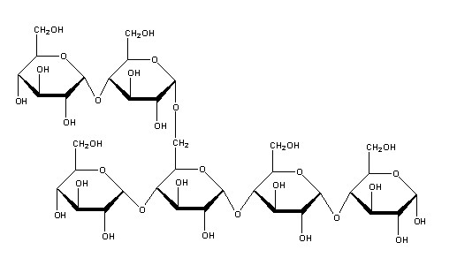

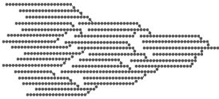

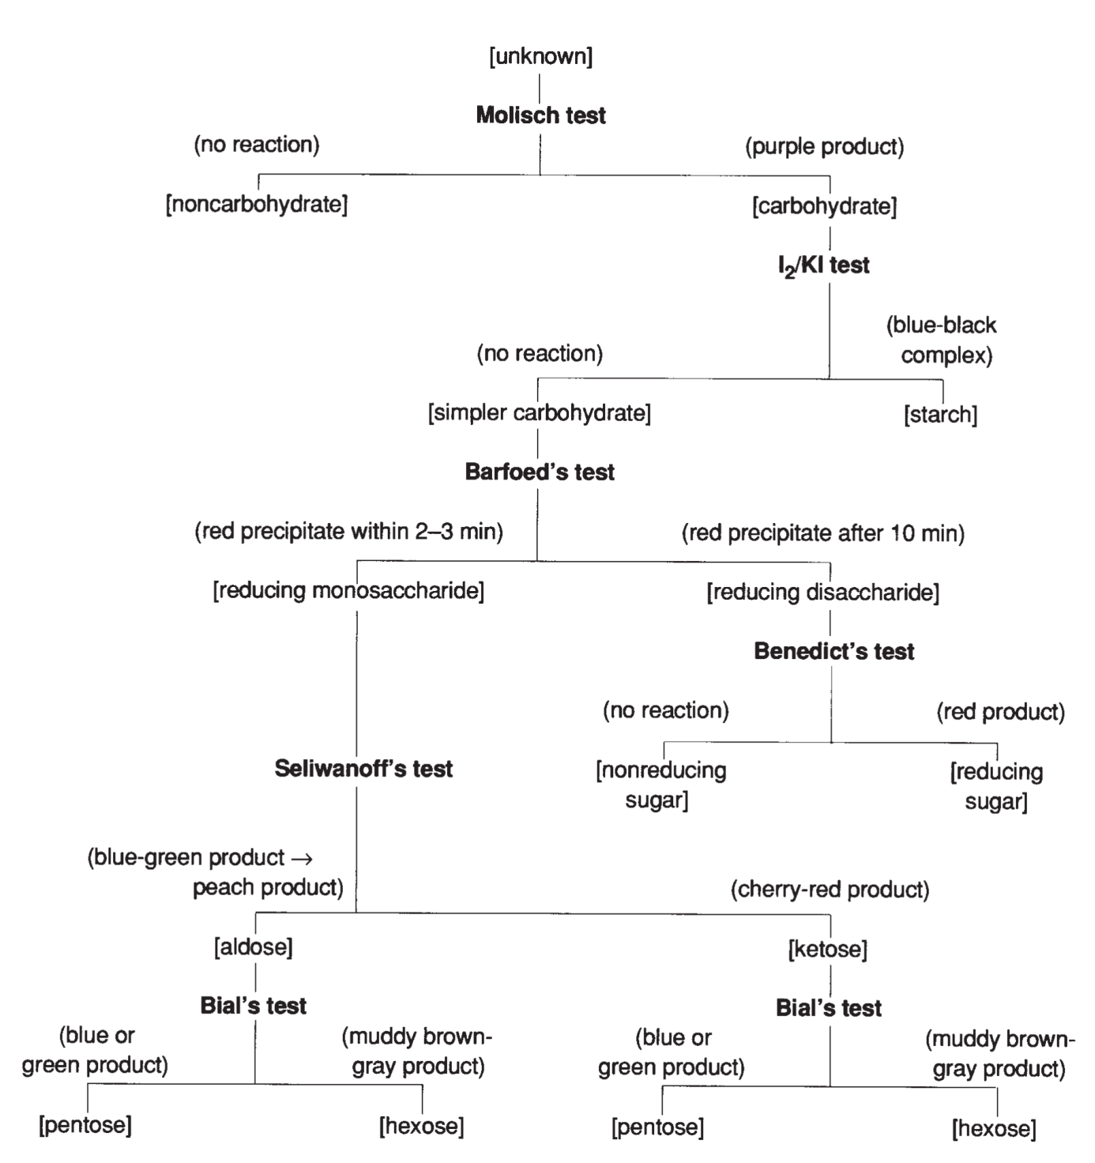

**PROCEDURE:**

1. In six test tubes labelled 1, 2, 3, 4, 5 and 6 prepare solutions of the following compounds by placing a spatulaful of solid in 5 ml of water: 1) xylose, 2) lactose, 3) glucose, 4) sucrose, 5) fructose and 6) starch. Add 5 ml of Benedict solution to each test tube and place them in the boiling water bath. Record your observation after 2 and 8 minutes.
2. To the sucrose solutions (tube 4) add 2 drops of concentrated HCl and return it to the water bath for another 2 minutes.
3. Label three test tubes 1, 2, and 3 and prepare solutions of following sugars by placing spatulaful of solid in 5 ml of water: 1) xylose, 2) glucose, 3) fructose. To each solution, add 5 ml of phenyl hydrazine solution and place in the boiling water bath for 15 minutes. Watch the test tubes carefully and note how long it takes for each osazone to form. Do not get the phenylhydrazone solution on your skin or clothing.

**DATA:**

**A.** Observation after 2 min Observation after 8 min

1: --------------------------------

2: --------------------------------

3: --------------------------------

4: --------------------------------

5: --------------------------------

6: --------------------------------

Note whether each of the compounds used is a monosaccharide, or a polysaccharide.

1. Observation: -----------------------------------------------------------------------------

Acetals are hydrolysed in acid solution, but not in base. The disaccharides are not broken down in Benedict solution, which is basic.

1. Observations:

1)-------------------------------

2)-------------------------------

3)-------------------------------