**FE 132 ORGANIC CHEMISTRY LABORATORY**

**EXPERIMENT 7: CHROMATOGRAPHY**

When determining the physical and chemical characteristics of an element or a compound, chemists must be certain the substance is pure. Most substances in nature, however, are mixtures, and so it is necessary for chemists to be able to separate a mixture into its various pure components.

* Some mixtures of solids can be separated by dissolving one or more components.
* Mixtures containing solid and liquid components can often be separated by simple decantation, filtration, or centrifugation.
* Volatile liquids can be separated by fractional distillation, taking advantage of the difference in boiling points of the component substances.
* Certain materials, such as iodine and naphthalene, pass directly from the solid state to the vapor state upon heating and can be purified by sublimation.
* Other mixtures can be separated by crystallization on the basis of the differences in solubility.

One of the most versatile and powerful separation techniques used by chemists is chromatography, of which there are several types. Chromatography is an analytical method that is widely used for the separation, identification, and determination of the chemical components in complex mixtures, many of which could not otherwise be resolved. The applications of chromatography have grown explosively in the last four decades, owing not only to the development of several new techniques but also to the expanding need of scientists for better methods of separating complex mixtures.

**Chromatography** techniques are methods used to physically separate mixtures of gases, liquids, or dissolved substances. It is particularly useful in identifying substances composed of several different components, like illicit drugs, paint samples and ink from writing instruments. Substances of similar composition will show separation in a similar manner. Substances can be classified this way but exact identification is not possible without further testing. Thus, it is considered only a **presumptive test**.

Separation by chromatography is determined by **the molecular size** and/or charge of the individual components in the sample mixture. In all forms of chromatography there is a **stationary (absorbent) phase** and a **mobile phase**. The stationary phase is the material on, or in which the separation takes place.

Chromatography is used by scientists to:

* Analyze
* Identify
* Purify
* Quantify

Qualitative Analysis – identifying chemicals (what kind?)

1. Species identification, e.g., "killer" bees can be distinguished from native bees by comparing gas chromatograms of cuticle extracts
2. Tracing contraband sources and detecting drugs in urine

Quantitative Analysis – finding concentrations (how much?)

1. Each peak corresponds to a separate component in the mixture
2. Area of each peak is proportional to concentration

Applications of chromatography

Chromatography is used to separate compounds in reaction mixtures both in the laboratory and on the industrial scale. However, technology has now advanced sufficiently to allow chromatographic techniques to be interfaced directly to other analytical methods. For example, gas chromatographs are routinely linked to mass spectrometers, and HPLC columns are linked to ultraviolet/visible spectrometers.

Types of Chromatography

* Gas Chromatography: This technique uses a gas as the mobile phase, and the stationary phase can either be a solid or a non-volatile liquid. If a solid stationary phase is used the technique is described as gas-solid adsorption chromatography, and if the stationary phase is liquid it is called gas-liquid partition chromatography. The latter is more commonly used, but in both cases the stationary phase is held in a narrow column in an oven and the stationary phase particles are coated onto the inside of the column.
* Liquid Chromatography: Liquid chromatography is similar to gas chromatography but uses a liquid instead of a gaseous mobile phase. The stationary phase is usually an inert solid such as silica gel, alumina or cellulose supported in a glass column.

High performance liquid chromatography (HPLC): The efficiency of a separation increases if the particles in the stationary phase are made smaller. This is because the solute can equilibrate more rapidly between the two phases. However, if the particles are made smaller, capillary action increases and it becomes more difficult to drain the column under gravity. Consequently, a high pressure has to be applied to the solvent to force it through the column.

* Thin-Layer Chromatography – Thin layer chromatography is similar to paper chromatography, but the stationary phase is a thin layer of a solid such as alumina or silica supported on an inert base such as glass, aluminum foil or insoluble plastic. The mixture is ‘spotted’ at the bottom of the TLC plate and allowed to dry. The plate is placed in a closed vessel containing solvent (the mobile phase) so that the liquid level is below the spot. TLC has advantages over paper chromatography in that its results are more reproducible, and that separations are very efficient because of the much smaller particle size of the stationary phase.
* Paper Chromatography:

In paper chromatography, the components or solutes of the substance being identified will travel at different speeds past the **stationary phase**. The components that are held less “tightly” by the stationary phase will travel the fastest along with the solvent or liquid phase. The distance each component travels from the origin is called the **solute front** and the distance the solvent travels is called the **solvent front**.

In paper chromatography the stationary phase is a sheet of absorbent paper, such as filter paper. A tiny drop of the mixture to be separated is placed on the paper near the bottom of the paper. A lightly drawn pencil line marks the location of the spot. This location is called the **origin**. The paper is suspended vertically in the mobile phase, a solvent or **eluent**. The eluent could be water or alcohol, or a solvent solution made from several reagents whose proportions are chosen to enhance their ability to "pull" along some substances in the mixture being separated better than others. We want each chemical in our mixture to have different attractions to the solvent so that they will travel at different speeds and be separated.

The origin must be above the surface of the eluent. The eluent rises up the paper by capillary action. When the eluent reaches the origin, the components of the mixture rise at different rates. The container must be covered to prevent evaporation of eluent. The **chromatogram** must be removed from the eluent before the eluent reaches the top of the paper.

Chromatography separates liquid compounds into individual components based on their specific affinity for a solid surface and specific solubility for different solvents. In paper chromatography, the solid surface is the cellulose fibers in the chromatography paper and the developer is the solution that is placed in the bottom of the developing chamber. The separation takes place through a process of absorption and capillary action. A minute drop of the mixture to be separated is placed at the bottom of the strip of chromatography paper, which holds the substance by absorption. The chromatography paper is then placed in a developing chamber with a solvent. The paper, which acts as a wick, pulls the solvent up the paper by capillary action, and dissolves the mixture as it passes over it. The components of the spotted mixture move upward at differing rates. The separated substances on the chromatography paper form a pattern called a chromatogram.

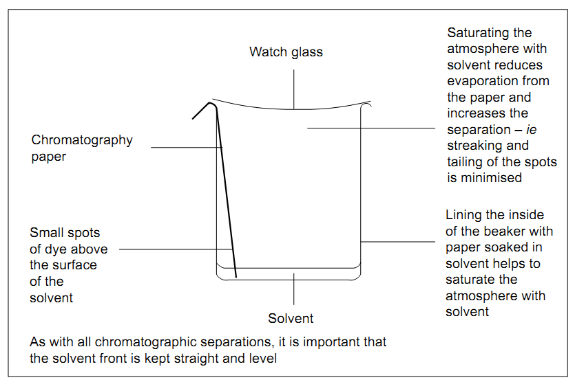

The distance that the pigments travel in across the paper is assigned a numerical value called an **R ƒ value or retention factor**. The R ƒ value is the distance traveled by a single solute divided by the distance traveled by the solvent. The further the solute travels, the greater the R ƒ value.

$$Rf=\frac{distance solute traveled (cm)}{distance solvent traveled (cm)}$$

**R ƒ values can never have a value greater than 1!** No solute is able to travel faster, and move farther than the solvent. An R ƒ value for a specific component is unique and can be used to compare to a standard.

Once the Rf value is known, the substance can sometimes be identified by comparing its Rf value with those reported in the literature. To check the identity of an unknown substance, it is usually necessary to run a chromatogram of a known sample simultaneously with the unknown.

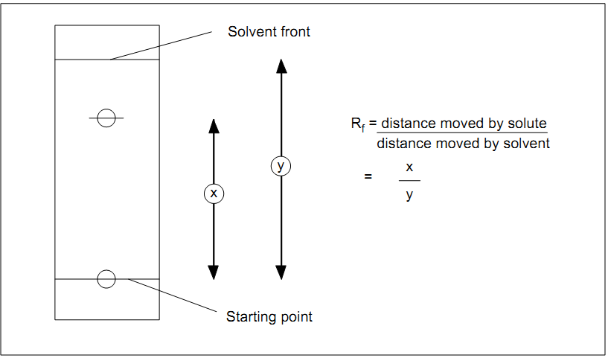

Procedure

1. Take the Whatman no.3 chromatographic paper. Draw a pencil line parallel to the bottom at 2cm distance from the edge of the paper.
2. Using a toothpick, apply a spot of dye solution on the pencil line.
3. Apply a spot of each standard colorant on pencil line, leaving a 2cm gap between two spots.
4. Airs dry the spots.
5. Place the chromatographic paper in a chamber containing % 0.1 NaCl solution. Cover the chamber with its lid.
6. After solvent front has moved ¾ of the total length of the paper, remove it from the chamber and air dry.
7. Compare the distances travelled by the spots of extracted colorants with spots of standard colorants.

Discussion Questions

1. What is chromatography?

2. What is the difference between the mobile and stationary phase?