**FE 132 ORGANIC CHEMISTRY LABORATORY**

**EXPERIMENT 6: PROTEINS AND AMINO ACIDS**

**Introductıon**

Proteins are essential components of every living cell and are utilised in the formation and regeneration of tissue. They contain nitrogen, carbon, hydrogen and oxygen: many contain sulphur, some contain phosphorous, and other elements such as zinc, iron and copper.

Proteins are composed of many small molecular units called amino acids linked together by the amide grouping. The amino group of one unit reacts with the carboxyl group of another unit, forming the amide. More links can continue to build and the chains get quite long. This amide group is also called a peptide bond, and proteins are often referred to as polypeptides.

The characteristics of proteins:

1. they are polymeric materials of high molecular weight,
2. they are of colloidal dimensions and as such will not pass through semi permeable membranes,
3. they are amphoteric, i.e., they may act chemically both as acids and as bases,
4. following complete hydrolysis, the hydrolysate consists entirely of amino acids,
5. In their polymeric structures the amino acid units are joined together in definite sequences and in definite three dimensional conformations.

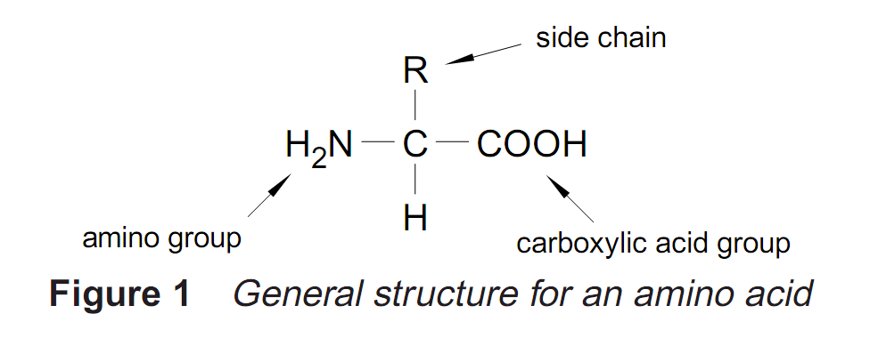

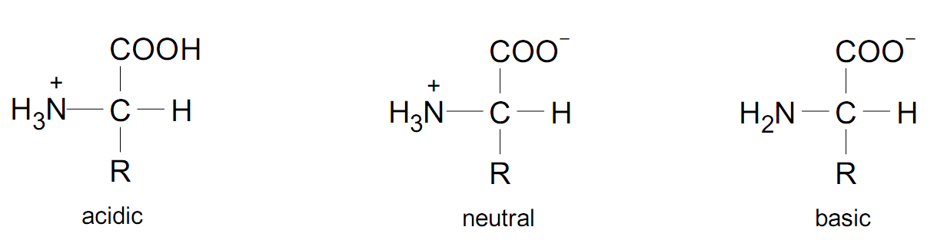

* Ninhydrin Test

Amino acids contain a free amino group and a free carboxylic acid group that react together with ninhydrin to produce a colored product. When an amino group is attached to the first, or alpha carbon on the amino acid’s carbon chain, the amino group’s nitrogen atom is part of a blue-purple product, as shown in Equation 2. Proteins also contain free amino groups on the alpha-carbon and can react with ninhydrin to produce a blue-purple product.

Amino acids that have secondary amino group attachments also react with ninhydrin. However, when the amino group is secondary, the condensation product is yellow. For example, the amino acid proline, which contains a secondary amino group, reacts with ninhydrin, as shown in Equation 3. Blue-purple and yellow reaction products positively identify free amino groups on amino acids and proteins.

* Biuret Test

The biuret test for proteins positively identifies the presence of proteins in solution with a deep violet color. Biuret, H2NCONHCONH2, reacts with copper (II) ions in a basic solution to form a deep violet complex. The peptide linkages in proteins resemble those in biuret and also form deep violet complexes with basic copper (II) ions in solution. The general or biuret complex formed between the protein linkages and the copper (II) ion of the biuret test is shown below.

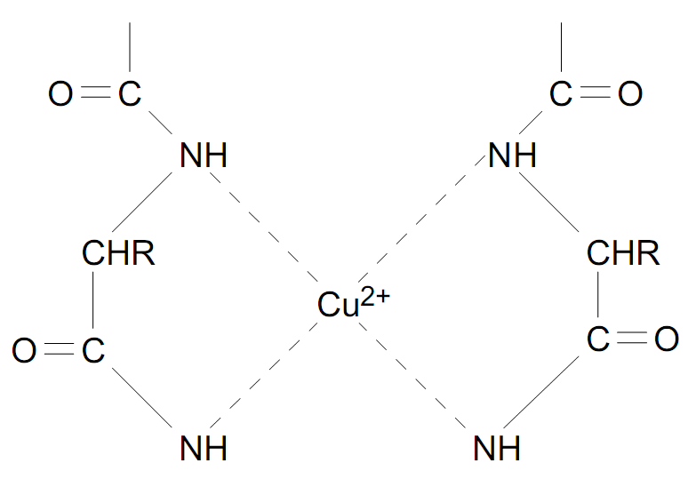

* 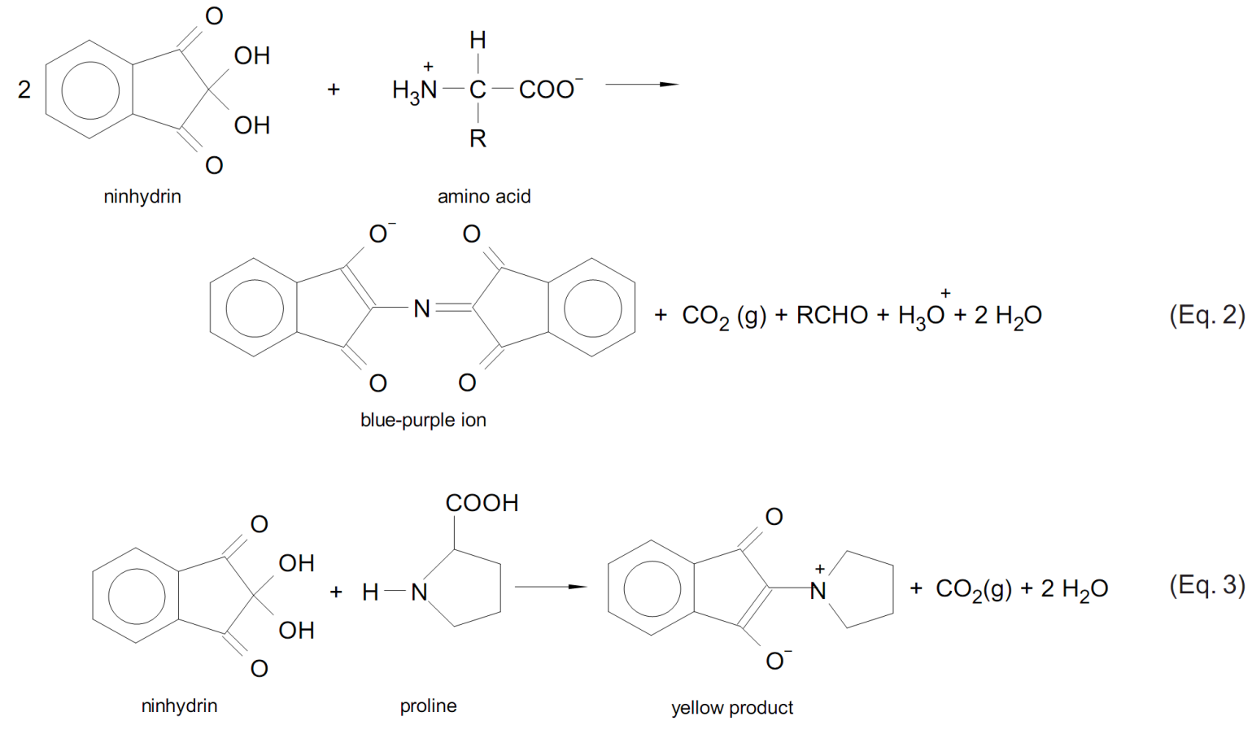Xanthoproteic Test

Some amino acids contain aromatic groups that are derivatives of benzene. These aromatic groups can undergo reactions that are characteristic of benzene and benzene derivatives. One such reaction is the nitration of a benzene ring with nitric acid. The amino acids tyrosine and tryptophan contain activated benzene rings and readily undergo nitration. The amino acid phenylalanine also contains a benzene ring, but the ring is not activated and therefore does not readily undergo nitration.

* Millon’s Test

Millon’s test is a test specific for tyrosine, the only amino acid containing a phenol group, a hydroxyl group attached to a benzene ring. In Millon’s test, the phenol group of tyrosine is first nitrated by nitric acid in the test solution. Then the nitrated tyrosine complexes mercury (I) and mercury (II) ions in the solution to form

* Hopkins–Cole Test

The Hopkins–Cole test is specific for tryptophan, the only amino acid containing an indole group. The indole ring reacts with glyoxylic acid in the presence of a strong acid to form a violet cyclic product. The reaction is shown in Equation 5.

The Hopkins–Cole reagent only reacts with proteins containing tryptophan. The protein solution is hydrolyzed by the concentrated sulphuric acid at the solution interface. Once the tryptophan is free, it reacts with the glyoxylic acid to form the violet product.

* Nitroprusside Test

The nitroprusside test is specific for cysteine, the only amino acid containing a sulfhydryl group (–SH). The group reacts with nitroprusside in alkaline solution to yield a red complex, as shown in Equation 6.

* 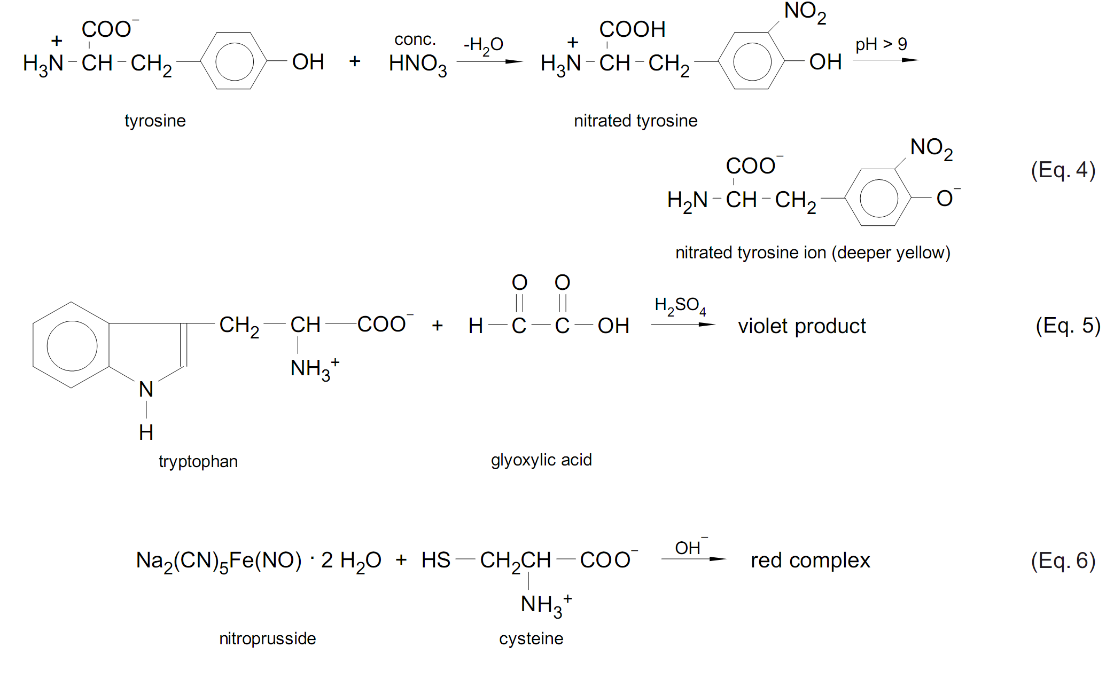Lead Sulphite Test for Cysteine
* Ehrlich Test:
* Sakaguchi Test:
* Nitroprusside Test
* Determination of Glutathione in Liver

Glutathione is an important tripeptide derived from glycine, glutamate, and cysteine. Glutathione is often found cells, at high levels and can be thought as a kind of redox buffer. It plays an important role during oxidation and reduction reactions. Liver is rich in glutathione. In this reaction Chicken liver, Saturated (NH4)2SO4 solution, Sodium nitro prusside solution, concentrated NH3 solution is used.

**PROCEDURE:**

**A.** The biuret test shows a colour with proteins but not with individual amino acids.

Place 5 ml of egg albumin solution in one test tube and 5 ml of glycine solution in another. To each test tube, add 5 ml of 15 % NaOH solution and 5 drops of dilute copper (II) sulphate solution. Mix well and observe.

1. The ninhydrin test shows the presence of the free amine group (-NH2). It is positive both for amino acids and for proteins containing such a group. Ammonia (NH3) is formed during the course of the reaction. It is the ammonia, in a complex reaction with ninhydrin that is responsible for the blue colour that constitutes a positive test.

Add 1 ml of 0.1% ninhydrin solution to 5 ml of albumin solution and to 5 ml of glycine solution. Describe the results.

1. To two of the test tubes, add 5 ml of egg albumin solution. Take one of the test tubes and heat the tube until boiling. Is there any precipitate? Observe.

To second test tube add 5 ml of ethyl alcohol, mix well and record your observation.

**DATA:**

1. Albumin

Glycine

**B.** Albumin

Glycine

**C.** Effect of heat

Effect of alcohol