FE 132 ORGANIC CHEMISTRY LABORATORY
EXPERIMENT 3: ExtractIon and IsolatIon of CaffeIne from tea leaves
This experiment illustrates the isolation of a naturally occurring product from plant material caffeine from tea leaves. The experiment will provide experience in handling relatively small amounts of material and at the same time you will be exposed to several techniques and procedures which are fundamental for survival in an organic chemistry lab.
INTRODUCTION
The use of tea as a stimulant dates back more than 2000 years. Its use became widespread in China around 700 A.D. and traders introduced it into Europe. The active ingredient in tea is caffeine.
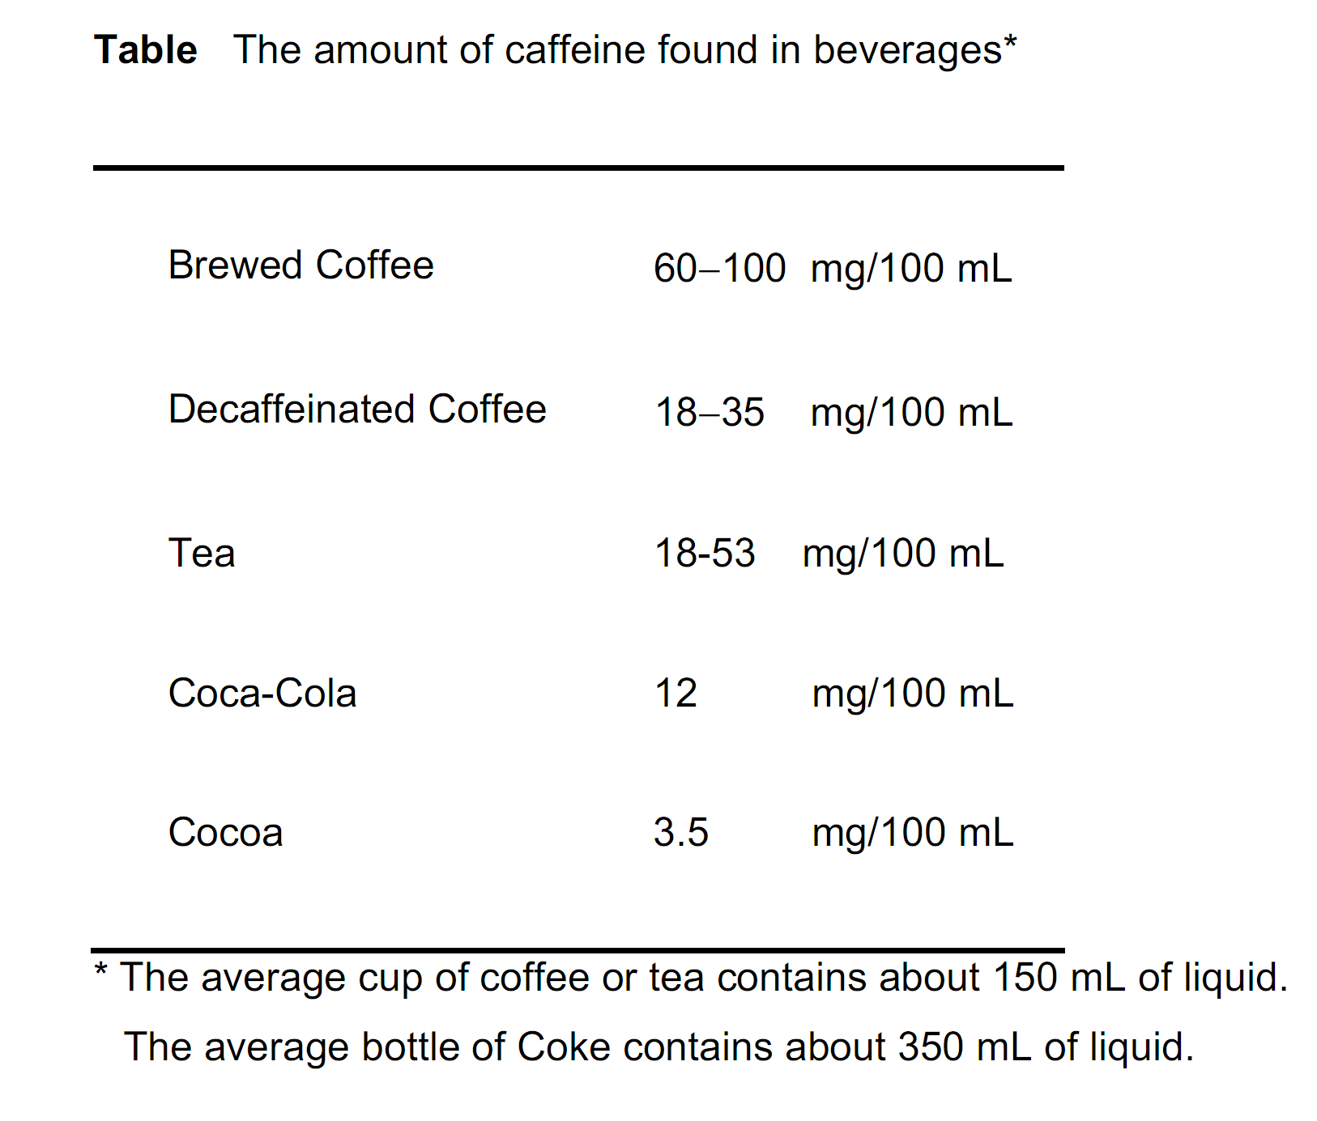

Structure of caffeine

Caffeine belongs to a large group of natural products that contain nitrogen and have basic properties. They are thus based upon ammonia (NH₃), which is also basic and can be considered a parent structure for these compounds. This group of natural products is called alkaloids.
Many alkaloids like caffeine have profound effects on the central nervous system. Many are mild stimulants. Moderate consumption of coffee or tea appears to be relatively harmless even over a lifetime. The toxicity of caffeine is quite low and the lethal dosage required to kill 50% of test rats is in fact 200 mg/kg of body weight. Heavier users of caffeinated products (greater than 5 cups/day) can develop a tolerance and dependence. Withdrawal symptoms include headaches and lethargy.
Caffeine occurs naturally in tea, coffee and cocoa nuts. The weight fraction of caffeine to tea or coffee can vary from between 2-5% depending on the source and quality. Decaffeinated coffee, prepared by extracting whole coffee beans with trichloroethylene, methylene chloride or supercritical carbon dioxide, generally contains much less than 1% caffeine. Caffeine can also be found in many headache remedies as a co-ingredient of acetylsalicylic acid (ASA).
The ASA suppresses the headache, while the caffeine component acts as a mild stimulant to make the individual feel better.

Isolation of caffeine from tea
The isolation of caffeine from tea leaves presents the chemist with a major problem: caffeine does not occur alone in tea leaves but is accompanied by other natural substances from which it must be separated. The major components of tea leaves are:
- Cellulose: The major structural material of all plant cells. Since cellulose is virtually insoluble in water it presents no problems in the isolation procedure.
- Caffeine: One of the major water soluble substances present in tea leaves. Caffeine comprises as much as 5% by weight of the leaf material in tea plants.
- Tannins: High molecular weight, water soluble compounds that are responsible for the color of tea. The term "tannin" does not refer to a single compound or even to substances having similar chemical structure. Rather, "tannin" refers to a class of compounds that have certain properties in common. They contain phenol groups, are acidic and are used to convert animal hides to leather [tanning].
- Flavonoid Pigments: Water soluble colored compounds that are widely distributed in plant life.
- Chlorophylls: Water soluble green plant pigments that enable plants to convert carbon dioxide and water to carbohydrates and oxygen [photosynthesis].
Experimental Procedure
- Extraction of caffeine:
- To a 400 mL beaker containing 5 tea bags add 100 mL of vigorously boiling water. Set the beaker on the hot plate and boil gently for 10 min. Stir the mixture carefully to avoid breaking any of the bags.
- Decant the hot tea solution into a 250 mL Erlenmeyer flask and press the bags with the bottom of a small Erlenmeyer to recover as much water as possible.
- Cool the aqueous solution to room temperature using an ice bath and pour it into a 250 mL separatory funnel.
- Extract [gently shake/swirl the mixture for at least 2 minutes] the tea solution two times, (30 mL and 25 mL) with dichloromethane [CH₂Cl₂]. Combine both extracts in a 125 mL Erlenmeyer flask.
- Dry the combined CH₂Cl₂ extracts with anhydrous sodium sulfate. Swirl for several minutes to allow enough time for the sodium sulfate to become hydrated with the water.
- Gravity filter the dry CH₂Cl₂ solution into a dry pre-weighed 100 mL round-bottom flask. Wash the filter paper and drying agent with about 1 mL of CH₂Cl₂.
- Remove the CH₂Cl₂ by rotavap the solvent, until about 5 mL of liquid remains in the round-bottom flask. Do not allow the flask to go dry or the caffeine may decompose.
- Place the round-bottom flask on a steam bath and evaporate the contents to dryness at low-medium heat. Weigh the flask to find the crude mass of caffeine.
- Preparation of the salicylic Acid derivative of caffeine
- Assuming that the caffeine extracted is pure, add equimolar amount of salicylic acid into the round bottom flask, followed by 2-3 mL of dichloromethane and heat the mixture to boiling.
- Remove the round bottom flask from the heat and add petroleum ether drop wise until a solid white precipitate just begins to form. Now add dichloromethane in drops so as to just dissolve the precipitate.
- Let the solution cool very slowly to room temperature and then put it on ice to aid the crystallization.
- Vacuum filter the crystals using a Hirsh funnel and rinse with petroleum ether.
- Leave the solid in a tared weigh boat, cover with a filter paper and leave it in your locker to dry until the next lab session.
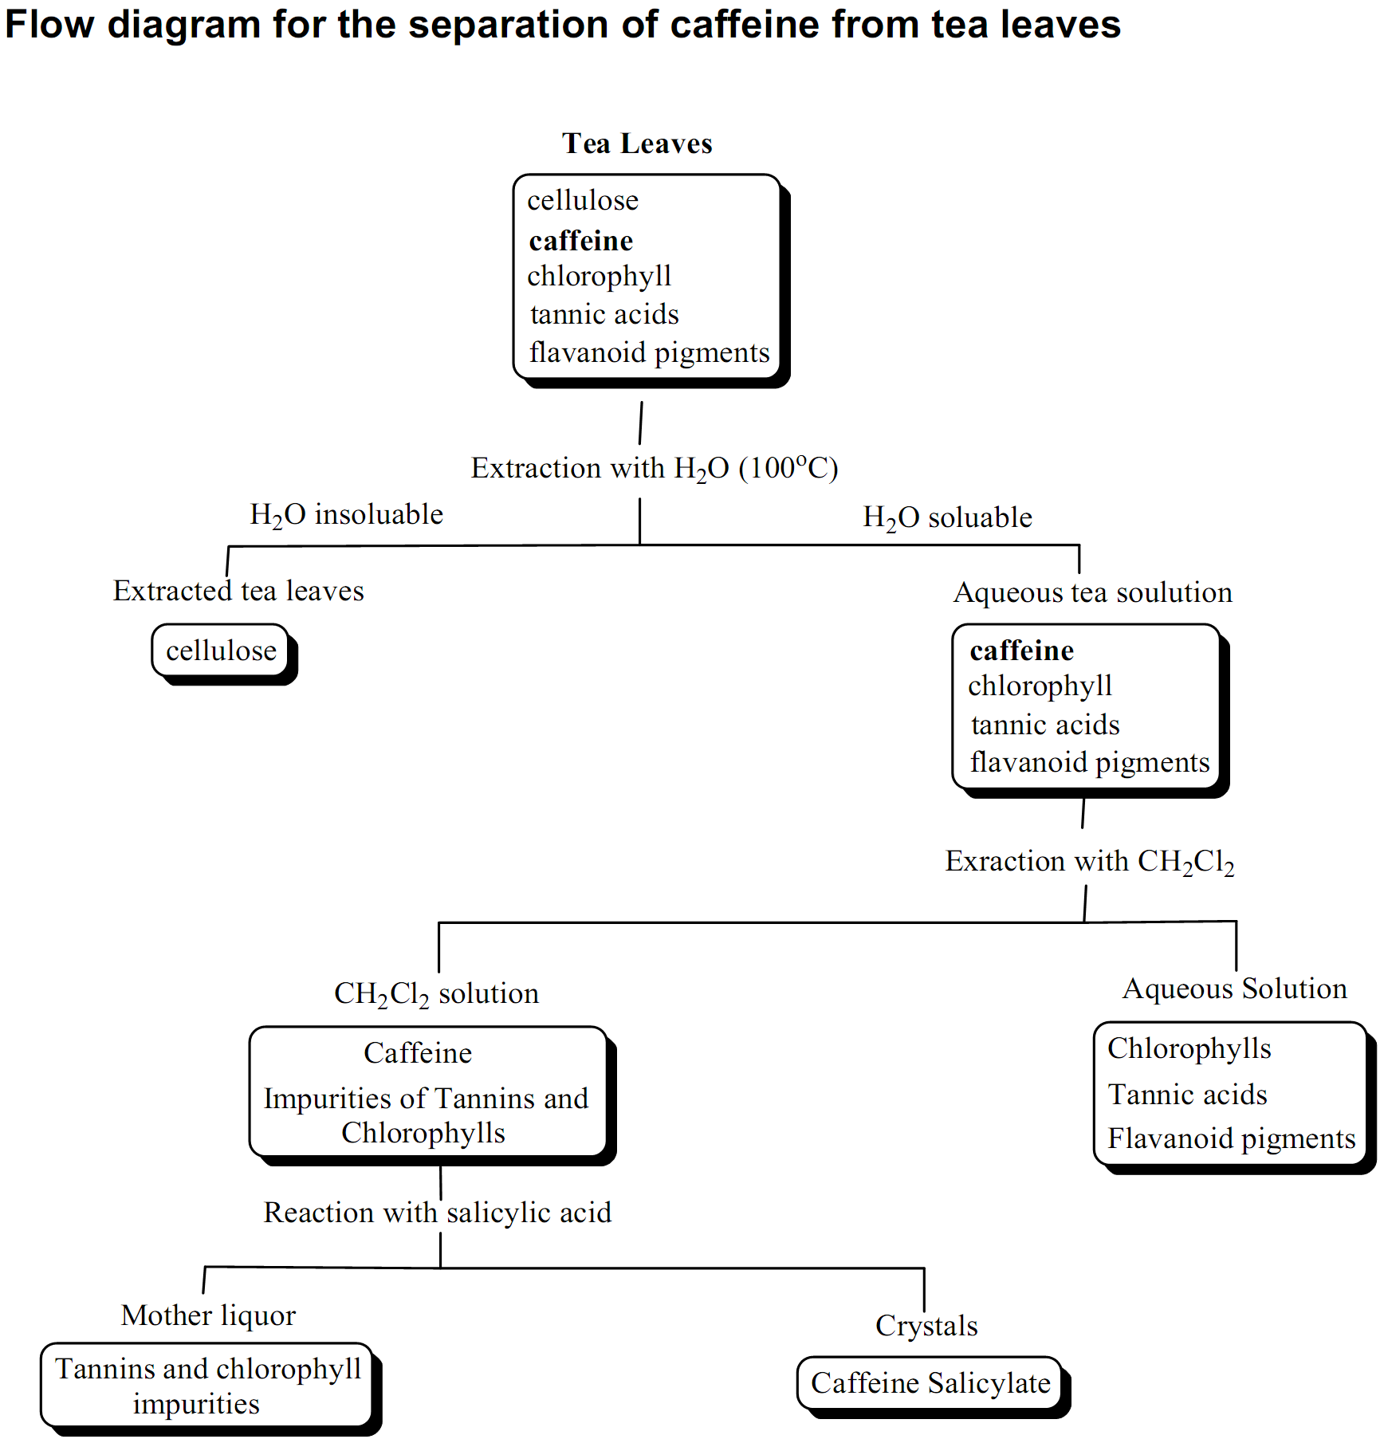
Post Lab Questions
- What is a natural source of Salicylic Acid?
- Salicylic Acid is classified as an Analgesic that is a precursor to Aspirin. Why is Salicylic Acid not used in place of Aspirin?
- Red Wine also has high levels of Tannins. What does this impart to the Wine?
- 1 g of caffeine can be dissolved in 46 ml of water at room temperature. In contrast, 1 g of caffeine dissolves in 5 ml of dichloromethane at room temperature.

4.1 Calculate the distribution coefficient of caffeine between water and methylene chloride.
4.2 How much caffeine would be extracted from 250 ml of water containing 500 mg of caffeine with one portion of 100 ml of methylene chloride?
4.3 How much caffeine would have been extracted if two 50 ml portions of methylene chloride had been used in part (b) above?
4.4 How much caffeine would be extracted using four 25 ml portions?
(Please note that several extractions using small amounts of solvent are more efficient than one single extraction using an equivalent total amount of solvent.)
- The solubility of caffeine in diethyl ether is 1g/530ml. How much caffeine can be extracted from 1L of water by a single extraction of 500 ml of ether?
- Suggest a reason why caffeine is much less soluble in a solvent such as hexane than in methylene chloride.

