FE 132 ORGANIC CHEMISTRY LABORATORY
EXPERIMENT 1: MELTING POINT DETERMINATION AND REFRACTIVE INDEX
INTRODUCTION
The melting point of a substance is the temperature at which the material changes from a solid to a liquid state. Pure crystalline substances have a clear, sharply defined melting point. During the melting process, all of the energy added to a substance is consumed as heat of fusion, and the temperature remains constant. It is difficult, though, to find a melting point. Usually, chemists can only obtain a melting range of a 2 - 3°C accuracy. This is usually sufficient for most uses of the melting point.
This is a physical property often used to identify compounds or to check the purity of the compound. Determining the melting point of a compound is one way to test if the substance is pure. A pure substance generally has a melting range (the difference between the temperature where the sample starts to melt and the temperature where melting is complete) of one or two degrees. Impurities tend to depress and broaden the melting range so the purified sample should have a higher and smaller melting range than the original, impure sample.
The melting point of a substance (the temperature at which a substance melts) is a physical property that can be used for its identification. It is a measure of the amount of kinetic energy (heat) that must be supplied to the particles of the substance in order to overcome the intermolecular forces (such as Van der Waals, dipole-dipole, and H-bonding) that confine them to the solid state. The determination of melting points is particularly important to organic chemists, since they generally work with solid molecular compounds that have low melting points (below 300°C) and which can be conveniently measured. Organic compounds are used in this experiment for the same reasons.
The Melting Point as a Criterion of Purity
A dilute solution of a liquid begins to freeze at a temperature somewhat lower than the freezing point of the pure liquid. The presence of an impurity causes a reduction of the freezing point of the sample. As the pure solvent crystallizes from solution, the concentration of the impurity must increase and the freezing point of the solution must fall. Thus, a sharp melting point (actually, a melting range of less than about 1°C) is often taken as evidence that the sample is fairly pure, and a wide melting range is evidence that it is not pure.
Mixture Melting Points
An identical or near identical temperature range of melting is not, in itself, proof of the sameness of two organic chemical samples. There are thousands of solid organic compounds that melt within any relatively short temperature range; overlap of melting points is therefore inevitable. If an unknown solid sample is believed to be a certain known compound, it is a relatively simple task to prove or disprove this belief by mixing the known and unknown together in relatively equal quantities. A 50:50 mixture will either be a pure sample of the known compound or a highly impure sample of the known compound. The melting point of the mixture will be identical to that of the known compound in the first instance or lowered and much broadened in the latter. This identification/confirmation procedure is referred to as the determination of a "mixed" melting point.
Mixtures of different substances generally melt over a range of temperatures, and melting is usually complete at a temperature that is below the melting point of at least one of the components. Thus, the nonidentity of two substances of the same melting point can often be established by determining that the melting point of a mixture of the two is depressed. If each individual sample melts "sharply" (and at the same temperature, of course), and if an intimate mixture of the two, made by rubbing approximately equal amounts together, melts over a wide range, the two substances are not the same.
Usually, however, you wish to establish the identity rather than the nonidentity of two samples, so it is unfortunate that the converse is not always true: the absence of a depression of the melting point or of a wide melting range of the mixture is not certain evidence that the two substances are identical in molecular structure and configuration.
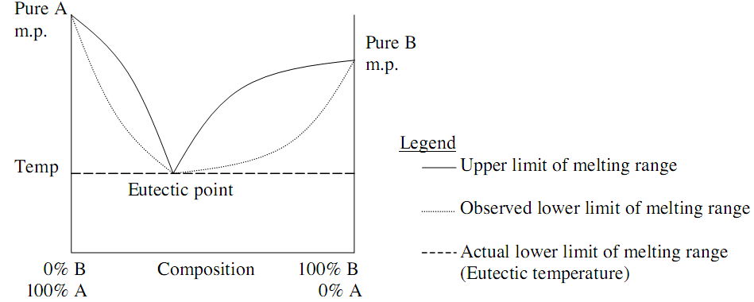

Molecular Weight

Although melting points do generally increase with increasing molecular weight, the first members of homologous series (compounds differing by only a CH₂) often have melting points that are considerably different from what would be expected on the basis of the behavior of the higher homology. In some homologous series of straight-chain aliphatic compounds, melting points alternate: the melting point of successive members of the series is higher or lower than that of the previous member, depending on whether the number of carbon atoms is even or odd. Sometimes, as with the normal alkanes, the melting points of successive members of the series always increase, but by a larger or smaller amount, depending upon whether the number of carbons is even or odd.
Polarity
As with boiling points, compounds with polar functional groups generally have higher melting points than compounds with nonpolar functional groups. In contrast to the case with boiling points, highly branched or cyclic molecules (relatively symmetrical molecules) tend to have higher melting points than their straight-chain isomers. The combined effects of branching or the presence of rings, then, are to reduce the range of temperature over which the liquid can exist at a vapor pressure of less than 760 Torr. In extreme cases, a liquid range does not exist at a vapor pressure of less than 760 Torr; at atmospheric pressure, the substance will sublime without melting. Hexachloroethane and perfluoro-cyclohexane behave in this way.
Melting Range
The melting range of a pure solid organic is the temperature range at which the solid is in equilibrium with its liquid. As heat is added to a solid, the solid eventually changes to a liquid. This occurs as molecules acquire enough energy to overcome the intermolecular forces previously binding them together in an orderly crystalline lattice. Melting does not occur instantaneously, because molecules must absorb the energy and then physically break the binding forces. Typically the outside of a crystal will melt faster than the inside, because it takes time for heat to penetrate. (Imagine an ice cube melting from the outside in, and not doing so instantly…)

The melting range of a compound is one of the characteristic properties of a pure solid. The melting range is defined as the span of temperature from the point at which the crystals first begin to liquefy to the point at which the entire sample is liquid. Most pure organics melt over a narrow temperature range of 1-2˚C, if heated slowly enough. Impure samples will normally have melting ranges that are both larger (>1˚C) and begin lower.

Taking the melting range of a sample is useful for two reasons:
1. Identification of an unknown sample (compare it’s observed melting range with that of known compounds)
2. Assessment of sample purity for a known substance. By comparing observed range for an actual sample to the known range for a pure sample, you can tell whether your actual sample is pure or contaminated (the range is depressed and broadened)
The presence of impurity has two effects on a substance’s melting range:
1. Melting range depression (lower end of the range drops)
2. Melting range broadening (the range simply increases. Often the low end drops a lot, the high end less so or sometimes not much at all.) A melting range of 5˚C or more indicates that a compound is impure.
Mixed Melting Points
That mixtures have depressed melting points, even when both components have comparable melting points when each is pure, provides a useful laboratory technique. Consider the following situation and flow chart. If an unknown candidate X melts at a temperature close to that of two potential candidates A and B, you can identify it by taking X+A mixed melting point, and X+B mixed melting point. If X is equal to either candidate, one of these mixed melting points will not be depressed. If the mixture with X+A is not depressed, X = A. If the mixture with X+B is not depressed, X = B. If both mixtures are depressed, then X ≠ A or B.
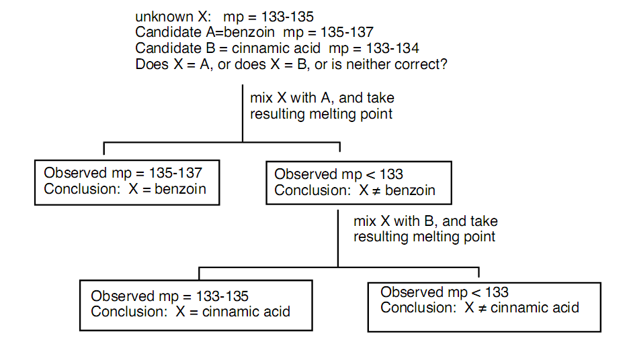

PROCEDURE
- Obtain a known substance (naphthalene) and determine its melting point.
- In this part, you will identify your unknown by matching its melting point with that of a known compound.
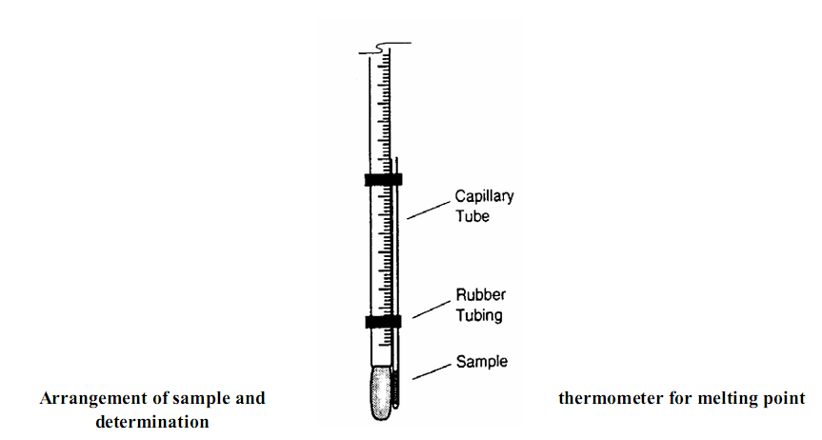
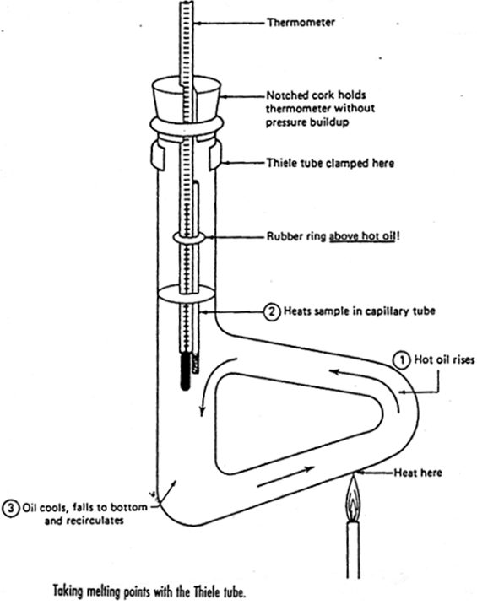
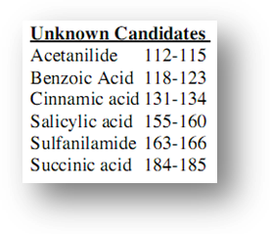
Experimental observations:
- Describe the physical appearance of each of the standard compounds.
- Are your melting points recorded as "ranges" and not "points?"
- Describe the melting process as you observed it.
- About how long does it take to do a melting point determination?
- What happened to the compound in the melt tubes after they were re-cooled?
Discussion questions:
- Strictly speaking, why is it incorrect to speak of a melting “point”?
- What’s the advantage of a finely powdered sample over a coarser sample? How will your melting range be perturbed with coarse sample?
- What’s the advantage of putting in a relatively small amount of sample as opposed to putting in lots and lots of sample? How will your melting range be perturbed with huge sample?
- Why is it desirable to heat the sample relatively slowly? How will your melting range be perturbed by heating too fast?
- You have a sample that you are sure is Jaspersium, which has a list melting range of 145-146.
- Suppose you run your sample and observe a melting range of 145-151. Is your sample impure, or did you heat too fast?
- Suppose you run your sample and observe a melting range of 139-145. Is your sample impure, or did you heat too fast?
- What could be the advantages or disadvantages of this method?
- How do you explain that acetone and ethyl alcohol lower the melting point of ice as well as the boiling point of water, whereas salt and sugar raise the boiling point and lower the melting point?

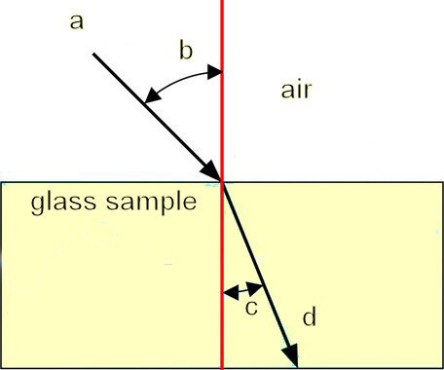
The refractive index

The refractive index or index of refraction is a ratio of the speed of light in a vacuum relative to that speed through a given medium (this quantity does not refer to an angle of refraction. In other words, as light passes from one medium to another as from air to water, the result is a bending of light rays at an angle. This physical property occurs because there is a change in the velocity of light going from one medium into another. Refractive index also describes the quantity that light is bent as it passes through a single substance. This involves calculating the angle at which light enters the medium and comparing that with the angle at which the light leaves the medium.
Another view rates each substance with its own refractive index. This is because the velocity of light through the substance is compared as a ratio to the velocity of light in a vacuum. The velocity at which light travels in a vacuum is a physical constant, and the fastest speed at which energy or information can travel. However, light travels slower through any given material, or medium, that is not a vacuum. This is actually a delay from when light enters the material to when it leaves; i.e., when some is absorbed, and another part transmitted.
A simplified, mathematical description of refractive index is as follows: RI = velocity of light in a vacuum / velocity of light in medium
Hence, the RI of water is 1.33; meaning that light travels 1.33 times faster in a vacuum than it does in water.
Since refractive index is a fundamental physical property of a substance, it is often used to identify a particular substance, confirm its purity, or measure its concentration. Refractive index is used to measure solids (glasses and gemstones), liquids, and gases. Most commonly it is used to measure the concentration of a solute in an aqueous solution. A refractometer is the instrument used to measure refractive index. For a solution of sugar, the refractive index can be used to determine the sugar content.
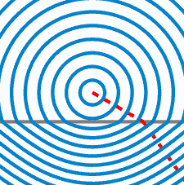
Degrees Brix (symbol °Bx) is unit representative of the sucrose content of an aqueous solution by weight. Brix is primarily used in fruit juice, wine making, starch and the sugar industry. Dissolution of sucrose and other sugars in water changes not only its specific gravity but its optical properties in particular its Refractive Index and the extent to which it rotates the plane of linearly polarized light.
Material | Absolute refractive index
Air | 1.0008
Water | 1.330
Glass, soda-lime | 1.510
Diamond | 2.417
Ruby | 1.760
