UNIVERSITY OF GAZIANTEP
ELECTRICAL AND ELECTRONICS ENGINEERING DEPARTMENT
EEE 340 DIGITAL DESIGN I
LABORATORY EXPERIMENT - 4
FPGA IMPLEMENTATION OF BASIC LOGIC CIRCUITS II

1. OBJECT
In this experiment you will implement some basic logic gates and circuits on FPGA by using Verilog HDL and synthesizer. You will also learn about levels of abstraction when designing a digital circuit and about verilog constructs assign and always.

2. THEORY
Verilog supports designing at many different levels of abstraction. Three of them are very important:
- Behavioral level
- Register-Transfer Level
- Gate Level
2.1. Behavioral Level
A behavioral design is meant to demonstrate the functional behaviour of a device without concerning itself about implementation details. Thus a behavioral design may include operations such as integer division or behaviour such as propagation delays that would be difficult or impossible to synthesize.

However, every design should start with a behavioral description. The behavioral description can be simulated and used to verify that all of the required aspects of the design have been identified. Often the output of a behavioral description can be compared to the output of a structural or RTL description to check for errors.

2.2. RTL

Register Transfer Level, or RTL design lies between a purely behavioral description of the desired circuit and a purely structural one. An RTL description describes a circuit’s registers and the sequence of transfers between these registers but does not describe the hardware used to carry out these operations. As a simple example, consider a device that needs
to add four numbers. In Verilog, given signals of the correct type, we can simply write:

s = a + b + c + d ;

This particular description is simple enough that it can be synthesized. However, the resulting circuit will be a fairly large combinational circuit comprising three adder circuits as follows:

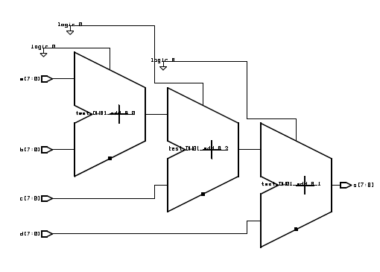

A behavioral description, not being concerned with implementation details would be complete at this point. However, if we were concerned about the cost of the implementation we might decide to break down the computation into a sequence of steps, each one involving only a single addition:

s = 0
s = s + a
s = s + b
s = s + c
s = s + d

where each operation is executed sequentially. The logic required is now one adder, a register to hold the value of s in-between operations, a multiplexer to select the input to be added on, and a circuit to clear s at the start of the computation. Although this approach only needs one adder, the process requires more steps and will take longer. Circuits that divide up a computation into a sequence of arithmetic and logic operations are quite common and this type of design is called Register Transfer Level (RTL) or “dataflow” design.

The RTL designer can trade off complexity (e.g. using more adders and thus using more chip area) against speed (e.g. having more adders means fewer steps are required to obtain the result). RTL design is well suited for the design of microprocessors and special purpose processors such as disk drive controllers, video display cards, network adapter cards, etc. It gives the designer great flexibility in choosing between processing speed and circuit complexity.

2.3. Gate Level

Within the logic level the characteristics of a system are described by logical links and their timing properties. All signals are discrete signals. They can only have definite logical values (`0', `1', `X', `Z`). The usable operations are predefined logic primitives (AND, OR, NOT, NAND, NOR gates etc.). This kind of design is the oldest digital logic design method. In this method the designer does all the work. The designer selects the low-level components
and decides exactly how they are to be connected.
2.4. Examples

2.4.1 Gate-level Design Example

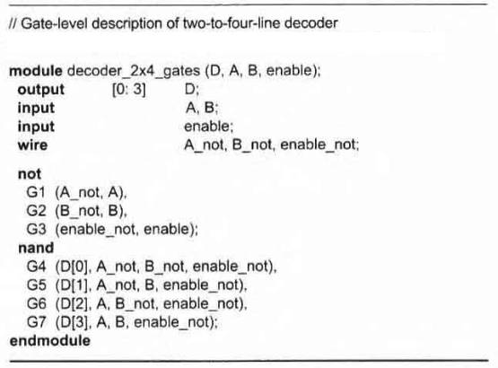

2.4.2. Behavioral Design Examples

// Example 1: Circuit specified with Boolean expressions using assign
// statement
module circuit_bln (x, y, A, B, C, D);
input A,B,C,D;
output x,y;

assign x = A | (B & C) | (~B & D);
assign y = (~B & C) | (B & ~C & ~D);

endmodule

- Continuous Assignment Statement: In Verilog the assign statement is used to assign a value to a net type (wire or tri) outside of an always block. The assign statement is implied when you assign a value to a wire during its declaration. Thus wire w1 = a ^ b; is the same as

wire w1;
assign w1 = a ^ b;

Note that continuous assignment statements are concurrent. In other words, if we write two assignment statements such as:

assign w1 = a ^ b;
assign w2 = c | d;

Verilog takes the two assignment statements as happening at the same time in parallel and not sequentially as shown. This is very different from most programming languages.

// Example 2: Combinational circuit specified with Boolean
// expressions using an always block
module ao2_gate(
output reg y,
input a, b, c, d);

reg tmp1, tmp2;

always @(a,b,c,d) begin
tmp1 = a & b;
tmp2 = c & d;
y = tmp1 | tmp2;
end

endmodule

- Always Block: always@ blocks are used to describe events that should happen under certain conditions. The sensitivity list (a,b,c,d) specifies which signals should trigger the elements inside the always@ block to be updated. always@ blocks are always followed by a set of parentheses, a begin, some code, and an end.

3. EXPERIMENTAL WORK
E1.
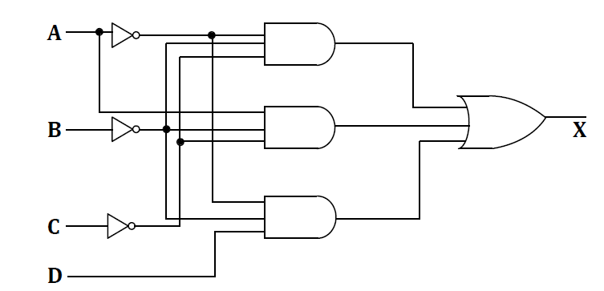

Do the following tasks:

a) Implement the circuit using behavioral description with an assign statement.
b) Implement the circuit using behavioral description with an always block.

When you complete your implementation for both tasks, have your circuit verified by lab instructor.

E2. Implement the circuit shown below in Verilog and simulate it using the provided testbench, taking delay into consideration. Delay of each gate is marked in red. Notice the glitch by inspecting the output waveform.

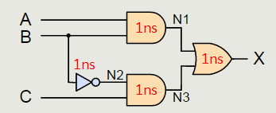

Implement propagation delay like this:

wire N1;

// AND gate with 1ns delay
assign #1 N1 = A & B;

Caution: The FPGA boards contain many exposed components that are sensitive to static electricity. Before touching the boards, try to remember to discharge any static electricity you may have built up by touching a grounded piece of metal. Also please hold the board from the sides when you have to and avoid touching exposed components on the board.

3. TESTBENCH
`timescale 1ns / 1ps
module Lab2_E2_tb;

// Inputs
reg A;
reg B;
reg C;

// Outputs
wire X;

// Instantiate the Unit Under Test (UUT)
Lab2_E2 uut (
.A(A),
.B(B),
.C(C),
.X(X)
);

integer k;

initial begin
// Initialize Inputs
A = 0;
B = 0;
C = 0;

// Wait 100 ns for global reset to finish
#100;

// Add stimulus here
for(k = 0; k < 4; k=k+1)
begin
{A,C} = k;
#5 B = 1;
#5 B = 0;
#5 ;
end

#10 $finish;
end

endmodule

